Embedding Numeracy within Catering

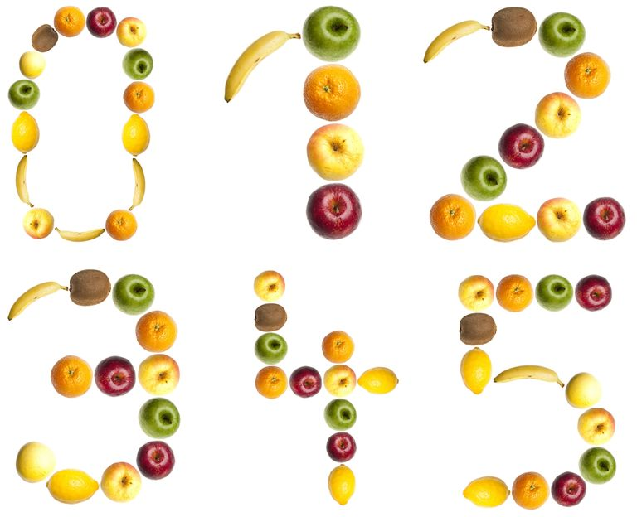

Contents

1 Aims of the project

2 Examples of embedding numeracy into day-to-day FEAST activities

3 Flow chart showing the learner journey

4 What do the levels mean?

5 What support is available to FEAST?

6 What is required from FEAST?

7 Brainstorming activities

**1 Aims of the project**

The project has a range of aims;

* Nourish to promote the numeracy project it runs in partnership with Baldwin Training. If successful this will help build a relationship between the City Council Adult Learning Disability department and Nourish, allowing the numeracy project to become a normal part of the FEAST trainee’s experience.
* Nourish to help FEAST embed numeracy within their service. Through the ongoing partnership FEAST will be supported in making numeracy a key element of their delivery. This will help to up skill the service users and increase their opportunities within catering and future progression.
* To allow Nourish to produce catering training resources available to FEAST and other organisations through the Excellence Gateway ([www.excellencegateway.org.uk](http://www.excellencegateway.org.uk)). The basic pack produced during this project will hopefully become a template for other recipes. From this both Nourish and FEAST can produce easy to use, differentiated recipe sheets.

**2 Examples of embedding numeracy into day-to-day activities**

The following resource sheets can be used to help us brainstorm activities that will support the learning of volunteers working with you at FEAST. Two different Chocolate Muffin recipes are included; one for Entry Level 2 and one that is suitable for Entry Level 3 and Level 1. To work in conjunction with the recipes are worksheets that can be used to highlight what FEAST activities will help embed numeracy.

|  |  |
| --- | --- |
| **Entry Level 1**  Entry Level 1 numeracy was about using simple numbers to support the set up of the cafe. Learners would be supported in tasks such as;   * Setting up the drinks area; tea, coffee, spoons * Greeting customers, such as; Good morning, good afternoon * Recognising coins |  |
| **Entry Level 2**  Entry level 2 numeracy can include using the Chocolate muffin recipe. At this level learners can manipulate things such as:   * cut in half ; cut into quarters * Learners can manipulate 15 minute intervals * Money can be understood when divided into manageable units; £3.50 could be described as £1, £1, £1 and 50p * Learners can double and half low numbers | **C:\DOCUME~1\JAMESA~1\LOCALS~1\Temp\msohtmlclip1\01\clip_image001.png** |
| **Entry Level 3**  At Entry Level 3 candidates can   * use numbers up to 1000 and understand equivalents, for example 1kg = 1000g. * Learners can double 2 digits which allow the manipulation of simple recipes. * Learners can use equipment such as thermometers, clocks and oven timers. |  |
| **Level 1**  Learners will use the same recipe as Entry level 3 but can manipulate the quantities, weights and measures.   * Learners can use negative numbers (for example -18°C freezer temperature) * Ratios can be used (for example 3:1 orange squash: water) * Learners can manipulate the recipe ingredients (for example; how many eggs would you need if you were asked to make 30 muffins?) |  |

FEAST Entry Level 1

Cafe Set-up

Examples of Entry Level 1 Numeracy

* Recognising coins
* Greeting customers – for example; welcoming people with good morning or good afternoon
* Recognising days of the week and times of the day

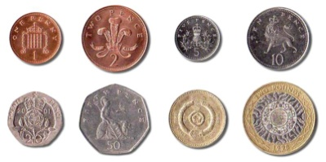

**Morning set-up**

Check the following things are ready; Jug of squash, Sugar, Tea bags, Coffee, Tea spoons, Jug of water, Mugs



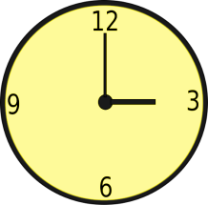FEAST Entry level 2

Catering Resources

Examples of Entry Level 2 Numeracy

* Cut things in half and in quarters
* Recognise 15 minute intervals
* Doubling and halving low numbers
* Handle simple amounts of money, for example £1, 50p



Entry Level 2

Chocolate Muffins

This recipe makes 12 Muffins

**Ingredients**

|  |  |
| --- | --- |
| 100g of plain chocolate  http://static.guim.co.uk/sys-images/Guardian/About/General/2009/12/13/1260723603944/Dark-chocolate-001.jpg | http://sg.sea.123rf.com/168nwm/robynmac/robynmac0807/robynmac080700139/3363180-cocoa-powder-on-a-silver-spoon--natural-light-on-white.jpg25g of cocoa powder |
| 250g of self raising flour  http://www.khanapakana.com/ShowImage.aspx?img=/recipe/articlefiles/08284cd4-8ccc-4458-84a8-308d864c8bbb-Self%20Raising%20Flour.jpg&w=250&h=250 | 2 tablespoons of baking powder  http://www.bigoven.com/uploads/bakingpowder.jpg |
| 150g of brown sugar  http://cooking724.files.wordpress.com/2010/05/brownsugar-1.jpg | http://thecookinggeek.com/wp-content/uploads/2011/03/pinch-of-salt.jpgA pinch of salt |
| 100g of plain chocolate drops  http://www.shamanshop.net/images/full/Images_GR/GR_219070.jpg | http://www.drgourmet.com/images/food/milkjug.jpg150ml of milk |
| 100ml of vegetable oil  http://www.bigoven.com/uploads/VegetableOil.jpg | http://www.lioneggfarms.co.uk/media/images/lion-egg.png2 eggs |

**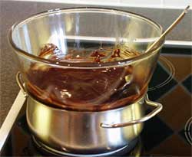Method**

1. Melt the plain chocolate in a bowl over a pan of

warm water.

2. Mix in the other ingredients.

3. Divide into twelve muffin cases

4. Place in a hot oven (Gas mark 6) at 220 °C for 15 minutes

5. Check they are cooked by inserting a skewer into the centre if it comes out clean they are done.

Enjoy!!!

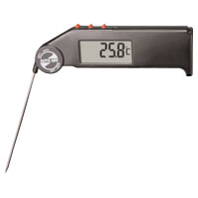FEAST Entry level 3

Catering Resources

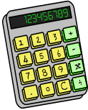

Examples of Entry Level 3 Numeracy

* Use numbers up to 1000
* Use equivalents such as 1kg = 1000g
* Use a thermometer and read a scale
* Manipulate two digit numbers

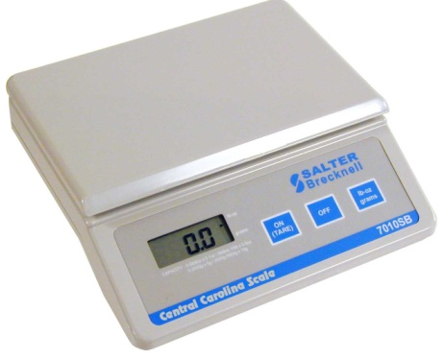

FEAST Entry level 3

Catering Resources

|  |  |  |
| --- | --- | --- |
| **Ingredients** | **Cost of the product** | **Cost for this recipe** |
| Plain chocolate | £1.20 for 100g |  |
| Cocoa powder | 75p for 25g |  |
| Self raising flour | 35p for 250g |  |
| Baking powder | 10p for 2 tbsp |  |
| Brown sugar | 80p for 150g |  |
| Plain chocolate (drops) | £1.50 for 100g |  |
| Milk | 30p for 150ml |  |
| Vegetable oil | 12p for 100ml |  |
| Egg | 60p for 2 eggs |  |
| **TOTAL:** | |  |

Entry Level 3

Chocolate Muffins

12 Muffins

**Ingredients**

100g plain chocolate

25g cocoa powder

250g self raising flour

2 tbsp baking powder

150g brown sugar

Pinch of salt

100g plain chocolate drops

150ml milk

100ml vegetable oil

2 eggs

**Method**

1. Melt the chocolate in a bowl over a pan of warm water.

2. Mix in the other ingredients.

3. Divide into twelve muffin cases

4. Place in a hot oven at around 220 °C for 10 minutes

5. Check they are cooked by inserting a skewer into the centre - if it comes out clean they are done

FEAST Level 1 

Catering Resources

Examples of Level 1 Numeracy

* Multiply a recipe
* Use negative numbers; for example -18°C for a freezer temperature
* Use ratios – for example; 1 part cleaning chemical to 2 parts water

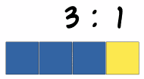

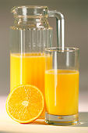

**3 Flow chart showing the learner journey**



**4 What do the levels mean?**

|  |  |  |
| --- | --- | --- |
| **National Curriculum**  **levels** | **Numeracy Levels** | **Vocational qualifications** |
|  |  | **NVQ Level 3** |
| **A-C grade GCSE** | **Level 2** | **NVQ Level 2** |
| **D-G grade GCSE** | **Level 1** | **NVQ Level 1** |
|  | **Entry Level 3** | **NPTC Entry Level**  **Skills for Working Life** |
|  | **Entry Level 2** |
|  | **Entry Level 1** |

**5 What support is available to FEAST?**

Nourish will be carrying out the initial skills assessments, running the diagnostic work and will provide FEAST/ service user with a clear list of areas that need further work.

Nourish (in conjunction with Baldwin training) will offer the learner support in completing workbooks that are related to the areas of ‘weakness’.

Nourish will provide resources to support FEAST staff to embed numeracy development in their training.

At the appropriate time, Nourish will carry out a re-assessment of the learner.

**6 What is required from FEAST?**

FEAST’s commitment to this project is to provide;

* Reliable learners who are active within the catering project.
* Time to work with the learners (initial assessment (1hour), workbooks (approximately 2 hours).
* Staff within FEAST actively embedding numeracy within their day to day catering activities.
* Training room for Nourish staff to use during the assessment, diagnostic and teaching.
* Internet connection for the laptop to run the assessment program.
* Coffee?

**7 Brainstorming activities**

Use this space to brainstorm the ways we can embed numeracy in and around cooking the daily FEAST menu. Indicate what numeracy levels you think the activities may be.

**Cooking the daily FEAST menu**

Use this space to brainstorm the ways we can embed numeracy in and around calculating the cost a FEAST buffet. Indicate what numeracy levels you think the activities may be.

**Costing a Buffet**

Use this space to brainstorm the ways we can embed numeracy in and around activities such as serving customers and handling money. Indicate what numeracy levels you think the activities may be.

**Serving customers/ handling money**

**Planning a buffet menu**