DEVELOPING STUDENT-STAFF PARTNERSHIPS TO ENHANCE DIGITAL CAPABILITIES TOOLKIT
PILOT PHASE

OUTSTANDING TEACHING, LEARNING
& ASSESSMENT PROGRAMME

ETFOUNDATION.CO.UK

Introduction

FOREWORD
The Education and Training Foundation (ETF) is the government backed, sector-owned national professional development body for the further education and training sector. Our role is to support the continuing transformation of our technical and vocational education system by developing has world-class leaders, teachers and trainers, leading to ever-improving learner outcomes, a more highly skilled workforce for employers, and a stronger economy, country and society.
Outstanding Teaching, Learning and Assessment (OTLA) is one of the ETF’s flagship programmes, and includes training courses, collaborative projects and our regional Professional Exchanges. Our collaborative projects aim to improve teaching, learning and assessment by giving practitioners the time and space to explore solutions to the challenges they face.
This strand of OTLA took a unique approach by exploring how the digital capability of students could be harnessed to support staff in their use of technology for teaching, learning and assessment. We wanted to discover whether the knowledge and enthusiasm of students would bring new insight and new approaches to the use of technology in learning.
This toolkit has therefore been created through the collaborative research of practitioner colleagues working directly with their students. We hope you find the approach practical and valuable in your organisation.
“It can be difficult for an organisation to drive change through the traditional CPD/ PLD mode of delivery because the FE and Training sector practitioners have a dual specialism and are for the majority part-time.
Student-staff partnership programmes are the perfect opportunity not only to foster staff development but also build student engagement by giving them an active role to take more responsibility towards their personal studies and also support others, staff and peers alike. Everybody wins!”
VIKKI LIOGIER
Head of Learning Technologies, Education & Training Foundation

This strand of OTLA has been managed by the Strategic Development Network (SDN), who have also edited this toolkit.
Acknowledgments:
We would like to thank all the students and staff who participated in these pilot projects, particularly the four project leads who drove this initiative – Andrew Dixon (Bishop Auckland College), Sky Caves (Basingstoke College of Technology), Luke Mullender (CityLit), Peter Kilcoyne (Heart of Worcestershire College).
We would also like to thank Vikki Liogier (Head of Learning Technologies at ETF) who initiated this programme of research and Linda Simpson (OTLA Programme Adviser) who supported us throughout.

HOW TO USE
In the body of this toolkit you’ll find:
1 An overview of a model student-staff partnership process with individual sections devoted to each of the phases that the projects have been through:
■ Preparation
■ Recruitment
■ Induction
■ Partnership Action
■ Sustainability
Each section has a detailed description, tools and resources, and a summary of top tips for action.
You will be able to adapt this approach to your own needs and circumstances.
Tools and resources that the projects developed have been included in each section for you to adapt and use. Each resource has a “Clickable Paperclip” to download.
2 An introduction to each project, its context and partners to help you consider it.
3 Case studies of several individual student-staff partnerships from each project. Links and downloads for case studies are available in a variety of formats (videos, blogs and documents).

AIMS AND OBJECTIVES
Outstanding Teaching, Learning and Assessment (OTLA) and Student-Staff Partnerships
The two overall aims of the OTLA programme are to:
■ Improve the quality of teaching, learning and assessment in the FE and training sector
■ Support increased professionalism for practitioners in the sector.
The objectives of this pilot programme were to ask, through four practitioner-led collaborative projects:
1 Can training organisations leverage students’ digital capability to support teachers and trainers in developing their understanding and effective use of learning technologies?
2 What are the most effective and sustainable approaches?
3 What are the challenges and barriers?

DIGITAL TEACHING PROFESSIONAL FRAMEWORK
In their research the projects adopted the Digital Teaching Professional Framework, a competency framework for practitioners across the FE sector. It was developed by the ETF in collaboration with Jisc and has been designed to focus on the benefits of good pedagogy supported by technology to enhance learning.
Click here for full details.

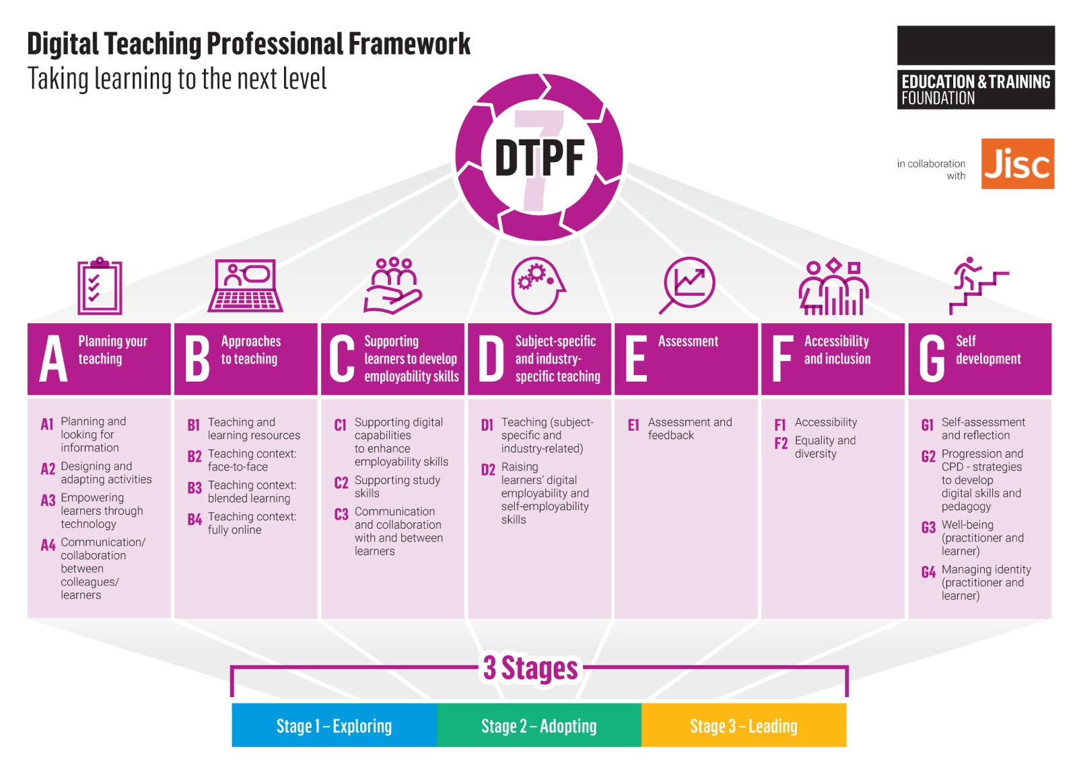

PROFESSIONAL STANDARDS
OTLA is driven by the values and expectations set out in the Foundation’s Professional Standards for Teachers and Trainers; a drive towards Ofsted outstanding (and similar success with other metrics); a clear focus on proven methodologies; intelligent and purposeful use of learner data and the need to work collaboratively across organisational boundaries and across a variety of provider types, to source the most effective teaching, and share this with the sector.
The projects have drawn on the ETF’s Professional Standards. To view ETF’s Professional Standards online click here.

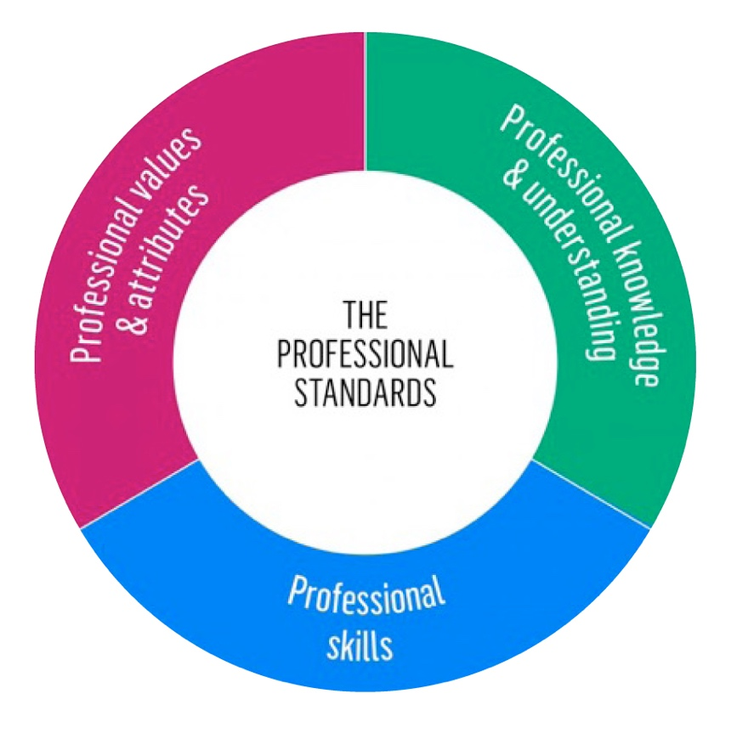

THE PROJECTS
Each project was a partnership of various combinations of FE, ACL and work-based learning providers trying out a range of approaches in their different contexts.
There were over 200 students and staff members participating in partnerships across the four projects.
Staff involved in partnerships were teachers, lecturers and trainers, supported by learning technologists, advanced practitioners
and managers.

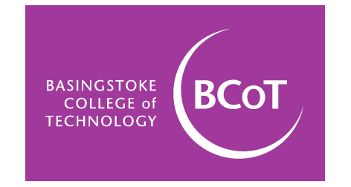with: City and Islington College and Mid Kent College
with: Darlington Borough Council Learning and Skills and South West Durham Training
with: Morley College and WMC – The Camden College
with: Aspiration Training Ltd, Blackburn College and Solihull College and University Centre

LIST OF TOOLS
Pg 10 PREPARATION Staff Role Specification
Pg 10 PREPARATION Student Role Specification
Pg 12 RECRUITMENT Staff Role Specification
Pg 12 RECRUITMENT Student Role Specification
Pg 12 RECRUITMENT Student Partner Commitment Statement
Pg 12 RECRUITMENT Example of recruitment call to action
Pg 15 INDUCTION Mentoring Record
Pg 15 INDUCTION Mentoring Presentation
Pg 15 INDUCTION Induction Slides
Pg 15 INDUCTION Staff Launch Workbook
Pg 15 INDUCTION Student Launch Workbook
Pg 15 INDUCTION Student Skills Assessment
Pg 15 INDUCTION Induction Slides
Pg 15 INDUCTION The Enhance Digital Teaching Platform
Pg 15 INDUCTION Digital Teaching Professional Framework
Pg 17 PARTNERSHIP ACTION Mentoring Record
Pg 17 PARTNERSHIP ACTION Mentoring Presentation
Pg 17 PARTNERSHIP ACTION Research log
Pg 17 PARTNERSHIP ACTION Lesson Plan

LIST OF CASE STUDIES
Basingstoke College of Technology
Pg 20 Project overview
Specialist Provision at Basingstoke College of Technology
Art and Design at Basingstoke College of Technology
Forensic Science at City and Islington College
Health and Social Care at Midkent College

Bishop Auckland College
Pg 21 Facebook
Quizizz
Quizizz
Clickview
WhatsApp
Kahoot
Snapchat
Instagram

City Lit
Pg 22 City Lit
City Lit
Morley College
WMC Camden College

Heart of Worcestershire College
Pg 23 Overall
Heart of Worcestershire
Aspiration Training
Solihull College
Blackburn College

The ‘Student-Staff Partnership’ Model

The projects were asked to adopt a five stage model to pilot the student-staff partnership model.

PREPARATION
Investing the time and energy to design your model of student-staff partnership is the critical first step in the process of successful implementation.

RECRUITMENT
Developing and implementing a robust recruitment process is an important step in establishing successful partnerships which encourage longevity and impact.

INDUCTION
A well-planned and executed induction makes sure that the partnerships are clear on their focus, the expected outputs and the ongoing support available to them.

PARTNERSHIP ACTION
Student-staff partnerships require a collaborative, supportive and respectful relationship with a clear understanding of roles, responsibilities and key activities to be undertaken.

SUSTAINABILITY
How can student-staff partnerships become part of a longer-term strategy to develop staff and to create outstanding, teaching, learning and assessment, enhanced through the use of education technologies?
The five parts of this section of the toolkit explore the learning from each of those phases and offers tools and “top tips” for you to use as you develop the approach in your own organisation.

PREPARATION
Investing the time and energy to design your model of student-staff partnership is the critical first step in the process of successful implementation.
The research identified the importance of student-staff partnerships being aligned with an organisational intent and strategy to improve use of digital technology to support teaching, learning and assessment.
As an isolated activity, without clear direction and senior leadership support, the investment in time and effort may not result in a significant impact. An important first step is to determine what you aim to achieve in terms of teaching and learning through a partnership model and how its success will be measured and evaluated.
Different partnership models have been tested by the providers involved, with examples shared in the Partnership in Action section.
When designing your model consider:
■ The leadership roles and who will drive the partnerships
■ The support infrastructure you have available for the partnerships from the outset. For example, the availability of an ILT manager or coordinator
■ The ways in which your model may need to be flexible to include learners with additional support needs and/or those learners who are not regularly on site
■ The key steps from initiating through to evaluation of the partnerships
■ The areas of focus that partnerships will align with, for example, elements of your quality improvement plan
■ The technology solutions you would like the partnerships to select and investigate
■ A clear role description and person specification for the students involved in the partnerships to support recruitment
■ The approach to recruitment, briefing and training to give the partnerships the best chance of success
■ The mentoring process which you intend partnerships to adopt
■ Accreditation (internal / external) which can be achieved for both students and staff
■ Supporting tools and documentation to facilitate partnership success
■ The timeline and timescale which will give partnerships the optimum chance of success, taking into account student intake dates, the time needed to undertake robust recruitment and launch activities and alignment with learning and assessment outcomes
■ The effective use of the Digital Teaching Professional Framework to identify progress and development of individual staff members involved in the partnerships. Click here to view the Digital Teaching Professional Framework online.

PREPARATION (continued)
As part of their preparation, Basingstoke College of Technology (BCOT) developed an illustration of the key steps in their approach, to provide a structure for all partnerships which they shared with stakeholders during the recruitment and induction stages:

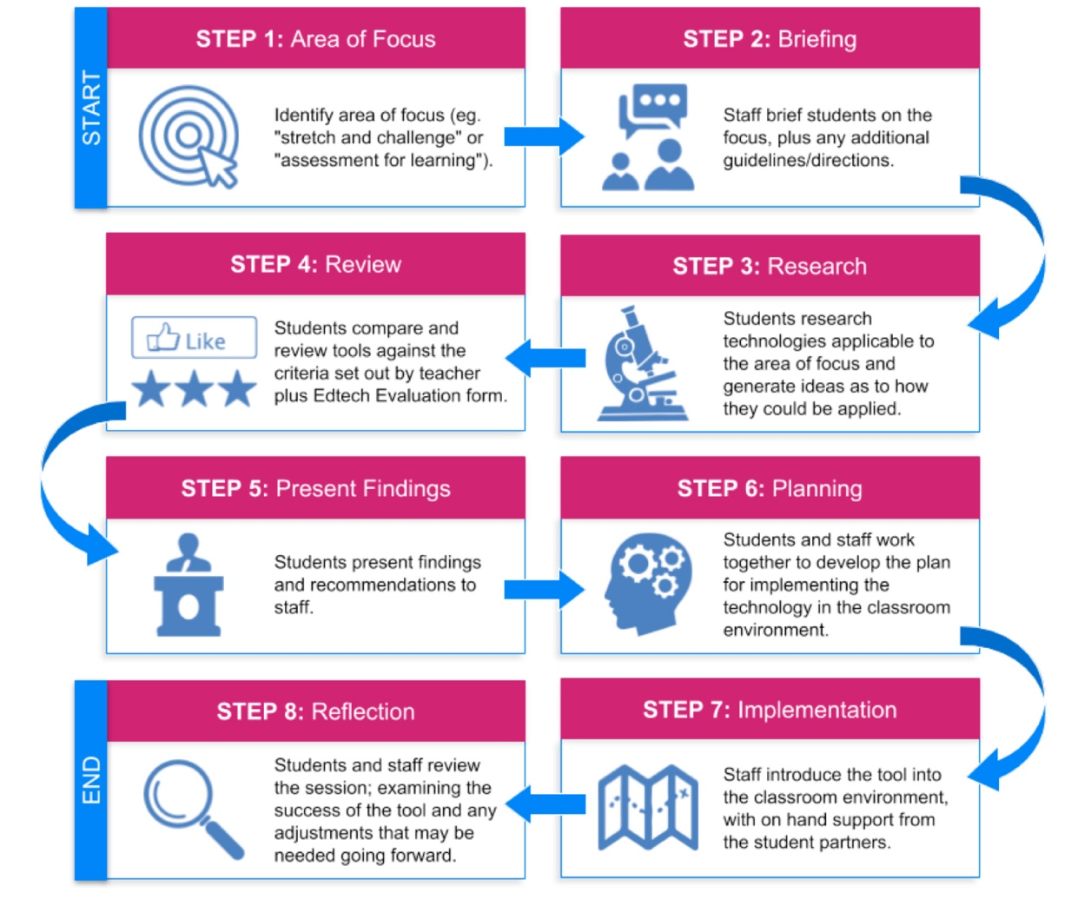
TOP TIPS
■ Make sure you have leadership support for a student-staff partnership model
■ Set out how much flexibility you can give partnerships in their choice of technology. Take careful account of existing IT policies, strategy, systems and access
■ If you have limited internal resources to support a partnership model, consider bringing in other providers to provide support
■ Give the partnership enough time to get established, to work together, to reflect on their findings, and share their success

TOOLS
HEART OF WORCESTERSHIRE COLLEGE:
Staff Role Specification Click here to download
Student Role Specification Click here to download

RECRUITMENT
Developing and implementing a robust recruitment process is an important step in establishing successful partnerships which encourage longevity and impact.
In all projects, the staff members were recruited first, with providers deploying a range of tactics to engage them. These included using e-flyers, general briefings and meeting with staff members involved in previous digital initiatives to build awareness and motivation. The focus was to engage staff members who had an interest in developing their knowledge and skills and the openness to learn from students to support this.
Being able to clearly articulate the overall aims of the partnership, any suggested or required areas of focus and the processes underpinning the mentoring relationship are an important output from this stage.
Having developed a clear role profile and person specification for student mentors during your preparation, you will be able to put in place a
suitable recruitment process. In particular, consider their existing level of digital literacy, their interpersonal skills and their commitment to the partnership model.
Aligned with your organisation’s teaching and learning strategy, consider the breadth of your partnership model:
■ do you want to include a range of curriculum areas?
■ how might you engage learners in the workplace?
■ what type or level of programme will the model work best in?
■ which partnerships may require more support than others?
The most successful approach to recruitment during the projects was when staff members who were signed up to the partnership model shared the opportunity with their own learners to encourage their participation.
It proved helpful to support this by providing a structured presentation to ensure consistency of message. You will find it useful if you have an existing digital leader network to ask for their support in both recruitment and supporting the learners once the partnerships are established.
The Digital Professional Standards also provided a helpful resource to allow educators reflect on their current level of knowledge and skills.

INCENTIVES
The projects identified a range of incentives to support recruitment and sustainability of the partnerships. These ranged from communicating the benefits, to putting a reward programme in place. The table below captures some of the incentives used along with some additional recommendations from the projects. When putting this into practice, consider aligning incentives with where students are in their own journey; for example, those nearer to the job market may be more engaged by an opportunity to gain additional accreditation to add to their CV.
Incentive for Staff
Continuous professional development opportunity
Encourage innovative approaches to delivery of the curriculum
Encourage students to support one another in their programme of learning to aid retention and achievement
Opportunity to achieve accreditation/qualification
National/local recognition for involvement
Opportunity to publish findings locally/nationally
Opportunity to develop evidence-based practice in the sector
Incentive for Students
Build self-confidence
Develop additional knowledge and skills over and above core curriculum
Build CV content to support job application
Building relationships with other students/staff
Contribute to the organisation and the course
Team build event for those involved
Opportunity to inform provider practice
Reward e.g. voucher for completion of partnership
Opportunity to achieve accreditation/qualification
National/ local recognition of involvement

TOP TIPS
■ Identify opportunities for partnerships which promote inclusivity. For example, explore ILT accessibility for students with additional support needs to engage a broad range of learners and staff
■ Explore the potential for your partnership model to be underpinned by qualifications, for example digital learning at work for staff members and mentoring accreditation for students
■ Take the time to plan the timing of the recruitment process to coincide with your preferred start dates for the partnership
■ The biggest gains could be with students who are reluctant at the outset but become more engaged and motivated as the project progresses if supported correctly. Emphasise the support which will be provided to encourage a more diverse group to engage

TOOLS
HEART OF WORCESTERSHIRE COLLEGE:
Staff Role Specification Click here to download
Student Role Specification Click here to download
BISHOP AUCKLAND COLLEGE:
Student Partner Commitment Statement Click here to download
BASINGSTOKE COLLEGE OF TECHNOLOGY:
Example of recruitment call to action Click here to download

INDUCTION
A well-planned and executed induction makes sure that the partnerships are clear about the expected activity and outputs and the ongoing support available to them.
Without exception, all the projects recognised the importance of a robust induction, with the recommendation that more emphasis should be placed on this stage than they were able to achieve during the short pilot period.
The projects identified key activities which would take place during induction to inform the partnerships:
■ Detailed briefing with all partnership participants to share the aims, models, delivery approach and evaluation
■ An initial digital skills assessment with staff and students
■ Provide a structure and support for the partnerships to identify their area of focus
■ Provide any documentation which is required to underpin the partnership model
■ Where appropriate, provide a briefing to partnerships on available ILT which they may wish to explore
■ Introduce partnerships to the ETF digital professional standards and bite-size modules
Click here to view the Enhance Digital Teaching Platform
■ Provide an opportunity for partnerships to work through any potential barriers to success
■ Explain the support infrastructure available for the partnerships

During induction, CityLit took participants through the roles and responsibilities of key stakeholders.
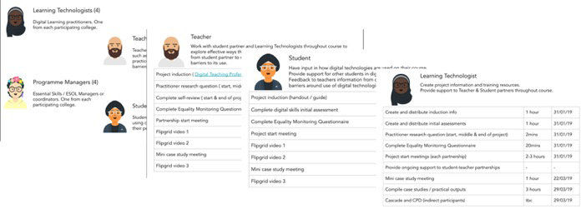
BCOT used the induction briefing to provide a structure for the partnerships to investigate and choose the technology solution they would be exploring in more detail.
Heart of Worcestershire College gave clear parameters to the partnerships to ensure the areas of research were aligned with the ILT strategy. Bishop Auckland College gave the partnerships freedom to explore technology which the students use on a day to day basis. This resulted in many of them choosing social media platforms as their focus.
The projects were introduced to the Flipgrid video platform as a means of sharing their partnership development with internal and
external stakeholders.

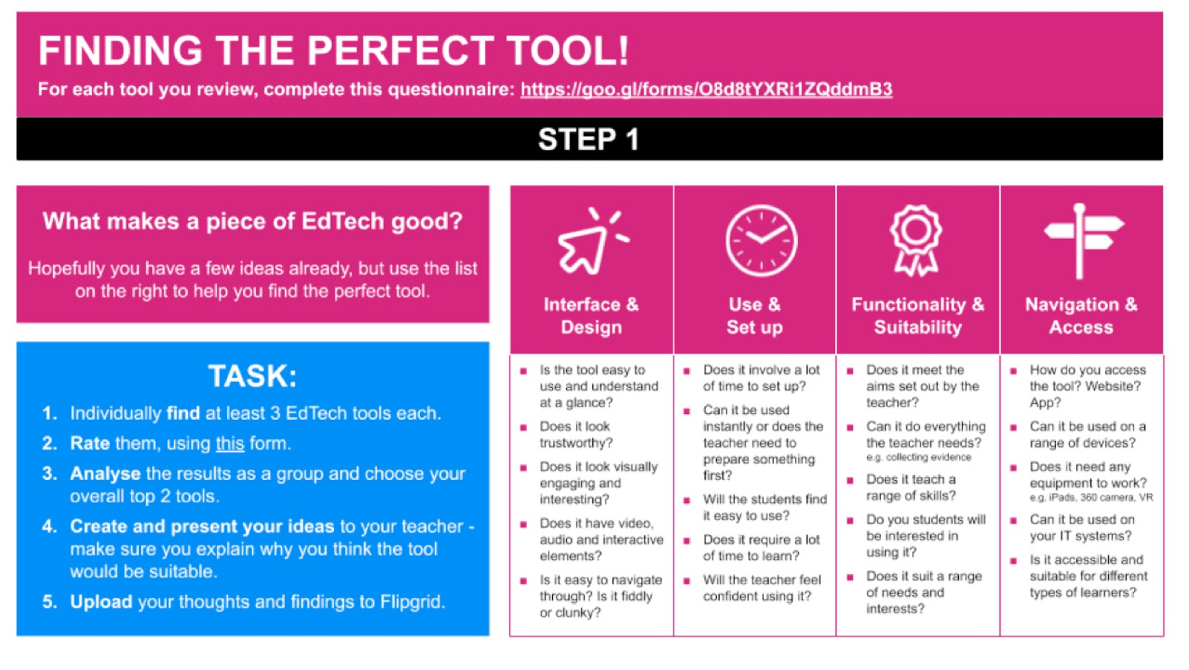
TOP TIPS
■ Use the induction period to explain the aims and objectives of partnerships, and how they can enhance both teaching
and learning
■ Share ideas and experiences of different types of technology to open minds to what might be possible
■ Invest the time and effort in explaining and developing the mentoring relationship – not just the area of technology focus
■ Baseline the staff and students existing skills using an initial assessment approach to help you and the participants to
measure success

TOOLS
HEART OF WORCESTERSHIRE COLLEGE:
Mentoring Record Click here to download
Mentoring Presentation Click here to download
BISHOP AUCKLAND COLLEGE:
Induction Slides Click here to download
BASINGSTOKE COLLEGE OF TECHNOLOGY:
Staff Launch Workbook Click here to download
Student Launch Workbook Click here to download

CITY LIT:
Student Skills Assessment Click here to view
Induction slides Click here to download
EDUCATION & TRAINING FOUNDATION:
The Enhance Digital Teaching Platform Click here to view
Digital Teaching Professional Framework Click here to view

PARTNERSHIP ACTION
Student-staff partnerships require a collaborative, supportive and respectful relationship to be formed from the outset, with a clear understanding of roles, responsibilities and key activities to be undertaken.
Providers tested a range of partnership models including one to one student to staff, student pairs to staff and full class to staff.
Each of these have their benefits, however, there was strong evidence to suggest that multiple students working together led to greater motivation, sharing ideas and arriving at different solutions to problems.

“The atmosphere the teacher created enabled students to communicate openly and honestly with their teacher about what they felt would help them to learn and succeed, knowing that she would be willing to listen and discuss options.”
BASINGSTOKE COLLEGE

Developing these partnerships is likely to be a significant shift in the dynamics of the normal student-staff relationship.
It’s crucial that all parties are approaching the partnership in an open and willing manner with a keenness to develop themselves whilst seeking to improve the learning experience for learners. Teaching staff are used to being the “experts” in the classroom when it comes to their particular specialist subject. For them to become the novice is quite a position-change, and one which some staff may find difficult to transfer into. However, the benefits of embracing the student’s digital expertise and knowledge, can prove to be very effective and enables the teaching practitioner to successfully learn from them. Students need to be encouraged and supported to feel confident in supporting / mentoring their teacher in a meaningful way.
It is often easier where there is already an established relationship. However, where the teacher actively engages with the student and draws on their expertise, student confidence increases and the partnership will flourish.
To ensure successful partnerships in action, it is essential that both the recruitment and the induction phases, each described in earlier sections, set clear roles and expectations and equip both students and staff with the necessary skills and behaviours to engage. You may wish to consider implementing a framework for students and staff members to follow during this phase to provide some structure to ongoing discussions, activity and evaluation.
In all projects students had access to a wider support network including ILT specialist staff. This could be further extended to support being available from more experienced student mentors and digital champions.
It is suggested that most partnerships would need to meet for at least one hour per week. The complexities of timetabling and availability of students and teachers should not be underestimated.

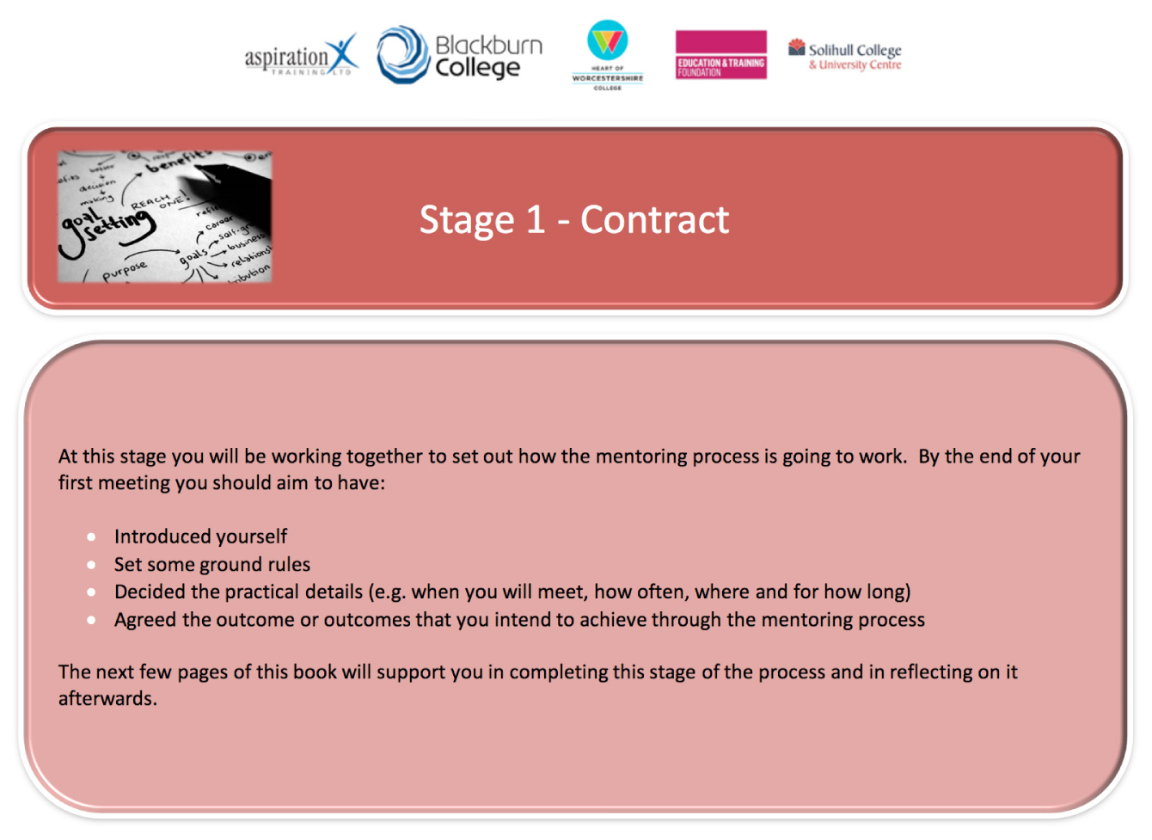
TOP TIPS
■ Build consistent expectations of the partnerships from the outset
■ Develop a framework and structure for partnerships to adopt
■ Set-up a wider network of support for students to engage with
■ Consider the time needed to develop the collaborative relationship and undertake the necessary activities

TOOLS
HEART OF WORCESTERSHIRE COLLEGE:
Mentoring Record Click here to download
Mentoring Presentation Click here to download
BASINGSTOKE COLLEGE OF TECHNOLOGY:
Research Log Click here to download
Lesson Plan Click here to download

SUSTAINABILITY
How can student-staff partnerships become part of a longer-term strategy to develop staff and to create outstanding teaching, learning and assessment, enhanced through the use of education technologies?

“I imagine this approach could be usefully embedded in our staff development practices going forwards.”
KERRY VANDERSTEEN, DIGITAL EDUCATION COORDINATOR AT CITY & ISLINGTON COLLEGE
“This project is crucial to the future development of our teaching, learning and assessment at the college”
SIMON COOK, PRINCIPAL AND CHIEF EXECUTIVE AT MIDKENT COLLEGE

The pilot projects were funded to explore the student-staff partnership model over a relatively short timescale (a single academic term). Since they only experimented with a single cycle of activity, their exploration of sustainability is yet to take place. However, the positive experiences that many of the partnerships have had have been very encouraging. Indications are that the participating providers valued the approach and plan to build this approach into their CPD and Ed Tech strategies.

ISSUES TO CONSIDER
■ Plan early and build student-staff partnerships into your academic cycle
■ Embed partnership recruitment and induction within learning programmes
■ This approach is most likely to succeed if you have the scaffolding in place, in other words an over-arching “technology for learning” strategy with ILT as a strategic priority
■ It is harder to deploy in smaller organisations who might not have dedicated ILT Teams, but it is possible as long as you tailor your approach and your ambitions to your resources
■ It is likely to be helpful to have multi-year cohorts with multi-year experiences, so for example a student progressing from a level 2 to a level 3 programme can continue in their partnership role and can support new students in their first year in a partnership
■ Build in celebration and “graduation”. Our projects held local events with certificates and refreshments to celebrate involvement
■ Encourage and support long-term relationships. The end of the project may lead to unforeseen opportunities and relationships

RESOURCES FROM THE EDUCATION & TRAINING FOUNDATION

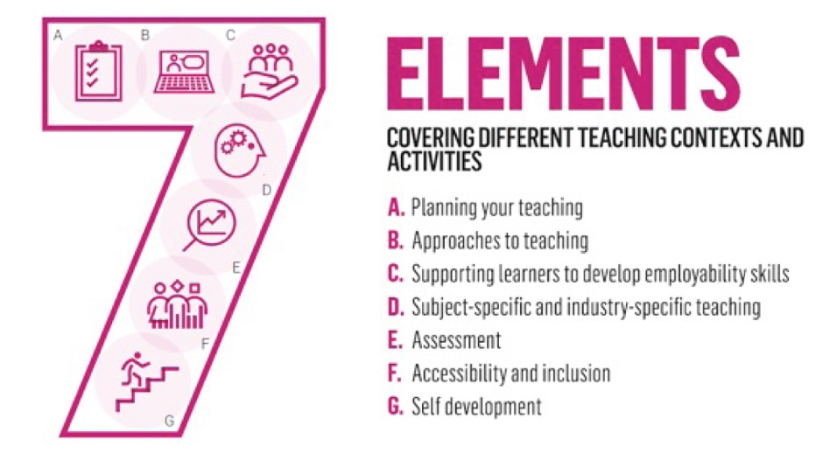
DIGITAL TEACHING PROFESSIONAL FRAMEWORK
The Digital Teaching Professional Framework provides a structure for practitioners in the FE and Training sector to understand how technology can be used to enhance teaching, as well as providing a pathway for development and career progression.
Click here to download

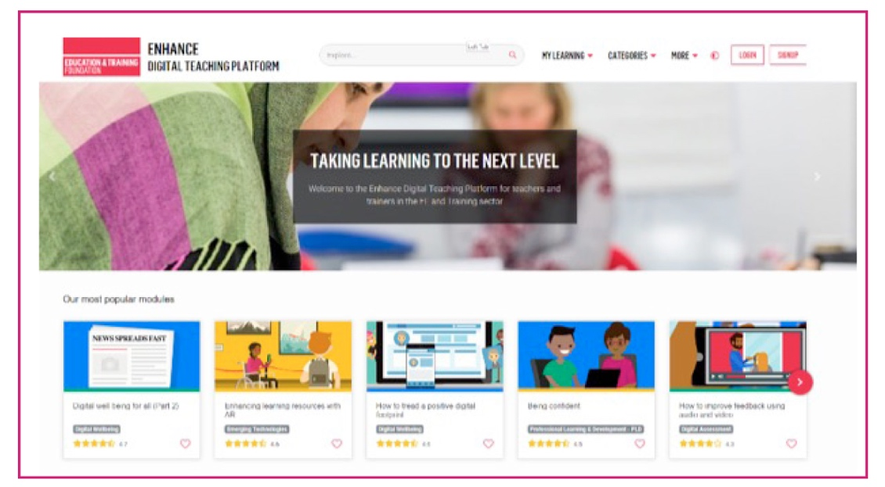

ENHANCE DIGITAL TEACHING PLATFORM
The Enhance Digital Teaching Platform is designed to help develop teaching and training practice using technology across the sector.
Launched in January 2019, the platform offers free to use bite-size modules to support innovation in teaching and training and to
improve learner outcomes.
Key features of the Enhance Digital Teaching Platform include:
■ Free, bite-size, certified online self-learning training modules mapped to the Digital Teaching Professional Framework
■ An achievements badge system
■ A user-centred, mobile-first design
■ Facilities to build a community of practice
Click here to download

Basingstoke College of Technology

THE PROJECTS
PARTNERS
■ MidKent College
■ City of Islington College
CONTEXT
Three General FE colleges participated in the project, piloting different partnership models; one-to-one, paired and group. Each college had an existing body of learners - digital ambassadors - who support their e-Learning teams.
The staff participants were a combination of eLearning professionals, teaching staff and learner support assistants from the respective organisations. The student participants were a combination of digital ambassadors and multiple small groups of learners from different subject areas. The project focused particularly on exploring technologies which promote accessibility and inclusion for learners with additional needs therefore looked for a selection of students who would be able to contribute to this area with first-hand experience.

“I think the learners really benefited from having the workbook and resources to guide them - it enabled them to work through the stages quite independently, which in turn gave them more of an opportunity to express their views and ideas.”
COURSE DIRECTOR FOR ART, DESIGN, MEDIA & GAMES AT BASINGSTOKE COLLEGE OF TECHNOLOGY

CASE STUDIES
Project overview Click here to view
Specialist Provision at Basingstoke College of Technology Click here to view
Art and Design at Basingstoke College of Technology Click here to view
Forensic Science at City and Islington College Click here to view
Health and Social Care at Midkent College Click here to view

Bishop Auckland College

THE PROJECTS

PARTNERS
■ Darlington Borough Council Learning and Skills
■ South West Durham Training
CONTEXT
Bishop Auckland College is a General Further Education College in North East England. Darlington Borough Council Learning and Skills are an Adult and Community Learning Provider, and South West Durham Training is an independent training provider. The locality of these organisations falls within some of the most deprived wards within England where many young people qualified for Free School Meals at school, and where unemployment among adults is still significantly high.
The project aimed to empower learners to take ownership of their own studies, particularly as many of the students are off site for most of their programme. The organisation leads set out to provide opportunities for learners to become more engaged with the programme, their peers and assessments through the use of digital technologies, feeding back to their teacher on how the technology has worked, advantages it brought to their studies and whether or not it could be used for the benefit of other students if planned effectively.
Each partner identified the use of learning technology to support teaching, learning and assessment as being sporadic. Whilst each organisation has learning coaches or advanced practitioners that deliver planned CPD to encourage incorporating learning technologies into the curriculum, practitioners use of technology to support delivery was varied.
The purpose of engaging with this phase of OTLA was to understand if a student-staff partnership model could improve upon staff member interest in and successful use of technology.
The project lead set-out to ensure the resulting case studies were student-led, presenting the students with an opportunity to review the technology they chose to use.

“The partnership model allowed us to test the technology together, sharing ideas and experiences throughout the process.”
TUTOR
“This has been a very successful project, driven by the students to encourage me to use new technology to support their learning.”
TUTOR

CASE STUDIES
Facebook Click here to view
Quizizz Click here to view
Quizizz Click here to view
Clickview Click here to view
WhatsApp Click here to view
Kahoot Click here to view
Snapchat Click here to view
Instagram Click here to view

City Lit

THE PROJECTS
PARTNERS
■ Morley College
■ Richmond and Hillcroft Adult Community College
■ WMC Camden College
CONTEXT
The project was a collaboration between the London Institutes for Adult Learning.
All participating organisations shared common challenges to using digital tools for adult learning courses:
■ Length of courses / time in the classroom - the majority of courses are non-accredited, short courses (10 weeks or less) and students and staff meet for just a few hours a week.
■ Digital capabilities of learners - learners’ digital capabilities and access to devices can vary greatly. As learners are not often in the college, supporting learners’ digital skills needs can be a challenge
■ Confidence / time to experiment for teachers – teachers also may not be in the college that often. e.g. City Lit has over 1,000 teachers with a third teaching less than 30hrs a year. All colleges also have a diverse curriculum and varied digital capabilities amongst teachers
Through the use of student digital champions and the opportunities for collaboration offered by technologies such as G Suite and Office 365 applications, the aim was to explore whether some of these challenges could be addressed.

“I am getting used to technology and I very much enjoy learning new things...... I would like to have suitable
facilities in class and be able to practise daily... It is an interesting new experience and it is nice to have all the worksheets available online.”
STUDENT

CASE STUDIES
City Lit Click here to download
City Lit Click here to download
Morley College Click here to download
WMC Camden College Click here to download

Heart of Worcestershire College

THE PROJECTS

PARTNERS
■ Solihull College
■ Blackburn College
■ Aspiration Training
CONTEXT
The project was delivered across three mid-sized general further education colleges; Heart of Worcestershire College, Blackburn College and Solihull College, and Aspiration Training; an independent learning provider.
Some of the project members currently work together as members of the Blended Learning Consortium (BLC). The embedding and enhancement of blended learning across the partnerships was the main, but not exclusive focus for this project.
All college partners already have a strong focus on the use of digital technologies and blended learning using the scheduled online learning and assessment (SOLA) model.
Aspiration Training Ltd, the only independent training provider in the project, uses the Smart Assessor portfolio platform to support
digital learning.
Partnerships were encouraged to experiment with existing in-house technology such as: Moodle, Office 365. Google Apps, AR, VR and the BLC resources. Students were also encouraged to research the use of new technology, including innovative apps.

“This project has hugely benefitted the practitioners. It has allowed them to increase awareness of new teaching technologies, to analyse learners’ abilities as well as helping to develop their research skills further.
It has also helped to improve the student’s confidence, research skills and networking ability which will help them in their future studies and future careers. They remarked that the project has ‘been beneficial just to do something different a bit different in college and learn new skills”.
PROJECT LEAD

CASE STUDIES
Overall Click here to download
Heart of Worcestershire Click here to download
Aspiration Training Click here to download
Solihull College Click here to download
Blackburn College Click here to download

