Case study: Google G-Suite for education — upskilling teaching and learning communities on Google apps for education

Outstanding Teaching, Learning and Assessment (OTLA 3) South Central programme (2017/19)

Which organisations were involved?
Greater Brighton Metropolitan College (GBMET) — created from the merger of City College Brighton and Northbrook College Sussex.

What was the purpose of the project?
Aware that a number of groups, platforms and mechanisms exist to share the experience of using Google G Suite for Education in secondary and primary schools, GBMET felt such opportunities were not in place in FE or, were at the very least, underdeveloped. We wanted to:
- Raise awareness of the tools available and share effective practice across the new college and community stakeholders so digital technology is used to improve teaching and learning
- Upskill staff to maximise the potential of Google Apps for Education
- Share training and existing innovative practice
- Train and get digitally literate students to help teachers and students with less digital confidence
- Encourage other organisations to share their practice.

What did the project do?
The project:
- Provided a team of teachers and IT support staff with Google Chromebooks and sent them off to Google Bootcamp to come back and train others
- Trained students to be digital leaders in order to help staff and students to develop their digital confidence through a Student Digital Leaders Programme
- Livestreamed the Google-focused Brighton Digital Festival Event on Technology and the Future of Education
- Livestreamed a staff development session with a digital innovation specialist from Basingstoke College of Technology who shared what they are doing.

What helped the project succeed?
- Starting small and then building up - training a few people well and then cascading knowledge, building ever larger circles of collaboration
- When training staff to use Google, picking a few useful themes and focusing on how to do them well (rather than teaching to the exam)
- When running events to share good practice, make sure there is an easy to access follow-up system to capture and facilitate collaboration
- When initiating projects that involve students, make sure they start at the beginning of the academic year

Financial investment was also important, giving people explicit jobs, for which they were remunerated. So was early marketing buy-in to drive recruitment and sell up-front the benefits of the project.

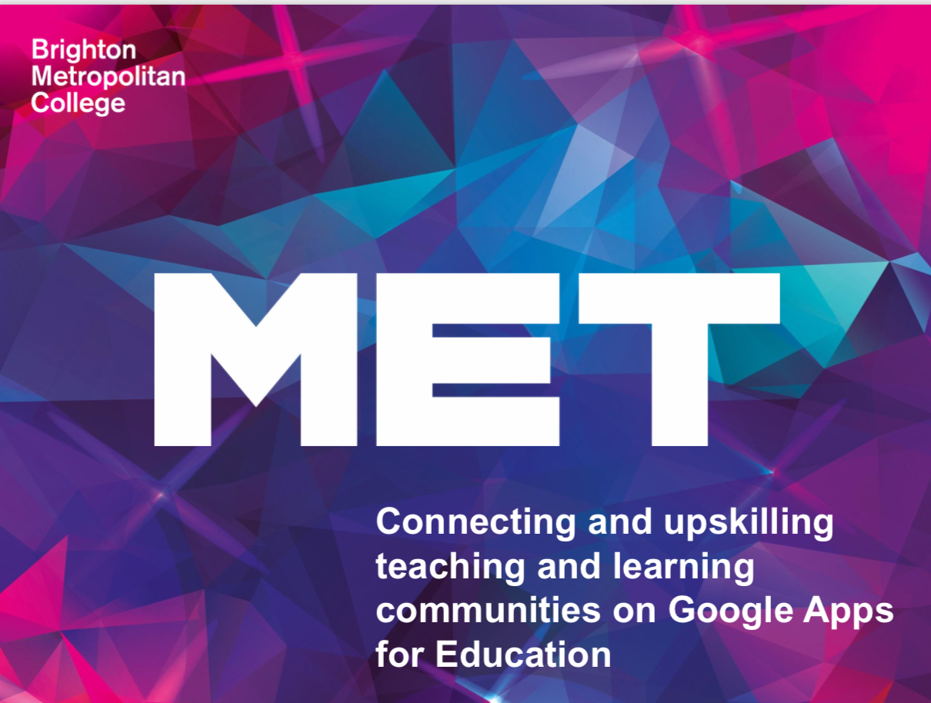
Picture 1 screenshot of the first slide of the project overview presentation

What difference did it make?
As a result of the Google Bootcamp, around 250 staff members were trained to use Google tools in addition to the teachers and IT support staff trained at the start of the project. A whole range of resources/services were created, including instructional videos, a study skills site and drop-in sessions for students, staff templates and face- to-face training, and a G+ Community. Some of the key outputs of the Student Digital Leader Programme include the creation by students of a booking system for their support, a tracking system to record the jobs they do and the feedback they receive, and publicity campaigns for the service. Where teachers were helped by students as part of the programme, they endorsed the students’ employability skills on LinkedIn.

After the project, GBMET plans:
- A follow up TeachMeet
- To promote and encourage the communication and collaboration channels and materials the project began
- To get teachers enrolled on the project to train more staff
- A separate project to continue the digital accessibility work started by this project.

Where can I find more information?
You’ll find more about this project:
- In the ETF Final report of the OTLA phase 3 (South Central) programme (undated)
- In the online project overview presentation: https://sites.google.com/ccb.ac.uk/otla-project
- In the online Student Digital Leaders Programme: https://sites.google.com/ccb.ac.uk/gbmetdigitalleaders/home
- Contact:
  - Martyn Howe, Assistant Principal Teaching, Learning and Quality, GBMET
  - Jim Lee, Course Leader Digital Media, GBMET
  - Rachael Thomas, eLearning Lead, GBMET
  - Marion Harrison, Head of Digital and Learning Resources, GBMET
  - Tyrone Knight, Systems Librarian, Basingstoke College of Technology
  - Scott Hayden, Digital Innovation Specialist, Basingstoke College of Technology.

