Outstanding teaching, learning and assessment: case study on operational project led by City Gateway on apprenticeships
Introduction
The lead organisation for this apprenticeship project is City Gateway. City Gateway began life under current CEO Eddie Stride in 2003, training 15 unemployed learners in job seeking skills. Now a registered charity with free school status, its mission is to support and empower young learners and families in Tower Hamlets. It currently provides key stage 4 courses, 16-19 pre-employment training, a children and families project and apprenticeship training.
The project partners are Mangroup PLC and Pulse Recruitment. The employers collaborating with examination and feedback on this project include Grant Thornton and The Doorstep Laundry.
In March 2015, City Gateway’s apprenticeship provision was examined by OFSTED and was judged as good with some outstanding features. OFSTED noted that “Outstanding partnership arrangements with large, local, corporate employers, particularly those in the professional and financial sector, are extremely effective and at the core of this provision.”
A soft skills’ profile, testing the acquisition and development of seven discrete skillsets (team building; initiative and leadership; demonstrating resilience; demonstrating professional behaviour; demonstrating awareness and confidence; using planning and thinking skills; communicating effectively) have been informally used across City Gateway’s formal education programmes but not in the apprenticeships programme.
It has been identified that ongoing skills’ profile monitoring and target setting for those who have moved into apprenticeships would be valuable in improving success rates in employment. This directly impacts upon outstanding teaching and learning in an apprenticeship setting, since it exposes the connection between supporting the technical apprentice skill with a network of key skills likely to initiate success at interview, and nurture effective collegiate working practices in the workplace; other outcomes might include raising the firm’s productivity.

“Soft skills play a major part in the recruitment process. [They are] essential requirements for all job specifications.”
Richard Thompson, CEO, Doorstep Laundry

41.2% of women in Tower Hamlets are economically inactive (62.6% of Bangladeshi women). These women face multiple barriers to engage with local services and the labour market. To this end, equality and diversity was embedded within the project: the project is actively supporting the entrepreneurial aspirations of its locale and augmenting the employment opportunities for some local Asian women through their women’s project, where the skills profile will be embedded.

Approach
The project aimed to:
- Refine the outcomes and measures used to track progress against the skills profile within the apprenticeships context.
- Develop capabilities to embed the application formally and systematically across the City Gateway organisation and monitoring these outcomes.
- Develop robust communications plan to support the change from start to finish.
- Identify the outstanding features of teaching, learning and assessment within the project.

Below is a visual manifestation of the skills’ profile assessment tool and accompanying action plan, used to measure soft skills development during the trial period.
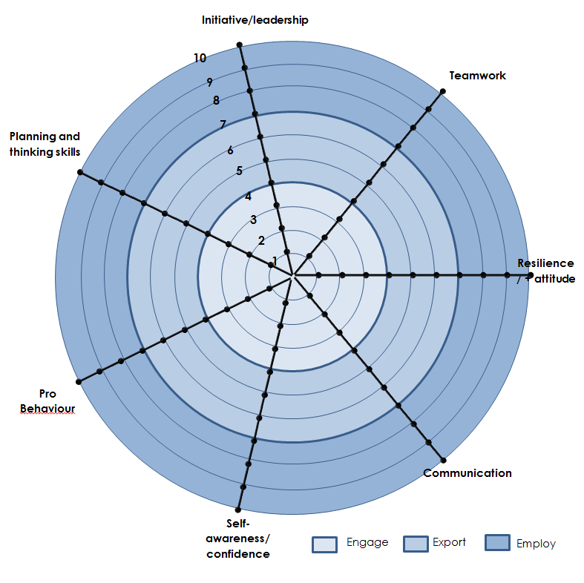

Date __________________ | Score | Reason | Action needed
Teamwork
Self-awareness and confidence
Resilience and positive attitude
Communications
Planning and thinking skills
Initiative and leadership
Behaviour and professionalism

An example of a lower descriptor for initiative and leadership (descriptor 4) is: “can complete work well under own initiative and can correctly define all of the key characteristics of leadership.” An example of the highest descriptor 10 for initiative and leadership is: “a range of leadership abilities are consistently evident, with evidence of clear organisation and discipline also evident. Meets deadlines without supervision and is always looking for ways to push themselves.”
It can be seen that the descriptors cover a wide range of skills development, with the higher descriptors providing considerable challenges. Employers and institutions setting high challenges for apprentice training are judged by OFSTED as key features of outstanding teaching, learning and assessment.
An initial pilot group of six apprentices completed the skills’ profile trial. An additional extended trial of the skills’ profile was implemented with five apprentices working at the employer partners Mangroup and Pulse: post- trial assessments are being carried out at the end of June.
The pilot group of learners were assessed both before and at the end of the trial: the assessments were conducted by the apprentices’ workplace line managers. The learners were also encouraged to self-assess their own progress.
Learners, assessors and employers were formally inducted into the skills profile, prior to the trials to ensure a clear and shared understanding of the tool and the process.
After the trial, feedback was given to the project team from learners and employers with a view to a) establishing the current efficacy of the tool and 2) further refining the tool.
The apprentice group in the extended trial group has elected to write a group report, summarising their assessment of the trial process and its outcomes.

Outcomes and impact
“As an employer who regularly assesses the performance of all of its employees, this [skills’ profile] is an easy to use, effective and transparent performance management tool to use, as a measure for the ongoing assessment and development of an employee’s impact and contribution within the company”
Richard Thompson, CEO, The Doorstep Laundry
Employers were able to interpret and apply this tool with minimal training: the tool gave the employer the opportunity to assess the apprentice in the language of teaching, learning and assessment, and involves the employer engaging with the apprentice in active dialogue and negotiation. This is an uncomplicated, but pithy individual learning plan: a progress review document accessible to a range of stakeholders within and outside the teaching and learning institution.
Of the initial pilot group of six apprentices, two learners achieved scores of 9 in the final scores in at least one soft skill and one learner scored the very highest score of 10 in three soft skills in the initial assessment. These results are examples of outstanding teaching learning and assessment, according with OFSTED’s statements that setting high expectations with learners meeting these should be judged as evidence of outstanding practice.
The five apprentices on the extended trial commented upon the visual clarity of the star tool and how it provided clear and immediate information on their skills scores. They also stated that the action plan was clear, succinct and helpful in charting actions to help determine next steps and further progress.

Lessons learned
It is recognised that the trial period was short and the apprentice pilot groups were small: the challenge here was to find objective impact in such a short time. However, the benefit was that the employers and apprentices have all been clearly identified and their feedback on the product and process has been comprehensive and inclusive: a small group was judged easier to map.
Further trials need to be run, in order to refine the skills profile and to measure further impact. The extended trial was the first milestone in this extended process.
It would be appropriate to run several more pilot trails, using more employers and over a period of 6 months, to help provide more comprehensive feedback and wider impact assessment.
The skills’ profile categories were judged to have been largely useful categories, with skills acquired under the categories augmenting and maximising employability. It would be useful to invite a wider cohort of employers to suggest soft skills categories, in order to ensure that the soft skills selected in the profile are the right skills needed by the employers.
Following refinements based on feedback, a comprehensive, systematic embedding of the skills’ profile is to be implemented across all of City Gateway’s provision and within all curricula.
Staff training days have been identified to induct current staff into how to 1) teach the soft skills and 2) use the skills’ profile tool. The skills’ profile will be included in initial induction packs for new staff joining the organisation.
City Gateway is committed to placing the skills’ profile at the heart of teaching, learning and assessment in their institution, whilst devising a robust system to monitor progress. This embedding of the project supports a sister project, developing an effective personal and social development curriculum to underpin all City Gateway courses. The two projects should be viewed as a collective embedded curriculum, nurturing and promoting effective and soft skills’ learning across the entire provision offered at City Gateway. This curriculum is eminently transferable.
City Gateway is communicating the value of the skills’ profile to key stakeholders. It is developing a robust system of communications to establish the skills’ profile initiative, from start to finish, and to effectively and systematically communicate this initiative to all stakeholders, through a suite of marketing materials.
As an additional, innovative spin off generated by this project, some learners at City Gateway are developing an app based on the skills’ profile tool, for peers to independently access via their phones. This will allow learners to a) acquire greater ownership of the skills’ profile and b) potentially generate modifications and extensions of the tool. In all likelihood, this project will help these learners understand that “real learning is about overcoming difficulties.”

Sustainability and transferability
Testing the acquisition and improvement of these soft skills supports the widest of curricula and would be particularly useful for transferability to areas where these skills are possibly under-practiced and under-valued: e.g. IT, accountancy, mathematics and science.
The skills in the profile are neither regionally nor culturally dependent, so they provide a relevant offer to institutions and employers involved in teaching learning and assessment in diverse contexts and locations.
The skills’ profile could easily be used and adapted to support the personal and social education curriculum in schools: smoothing the journey from school to college to employment.
The planned development of a phone app, based on the use of the visual star tool, is regarded by the project team as an innovative extension and application of the project: this was not envisaged at the outset. This will sustain the project into a new phase and the app can be shared and adapted with other institutions and employers.
The embedding outcomes mapped by City Gateway are comprehensive and far-reaching, seeping into the fabric of its diverse curricula, and will ensure that the project is developed and sustained over a considerable period of time at City Gateway.
“The next step for us as an organisation is to roll the tool out across our apprenticeship programme. To this end we will embed assessment against the skills profile in apprentice appraisal processes so that it forms an integral part of how we prepare learners for the workplace and assess and support them once they are in the work place, thus increasing the likelihood of them entering sustained employment.”
Emma Goulds, Strategy Manager, City Gateway

Case study written by Andy Cobb, Peer Advisor, supported by Emma Goulds, City Gateway

