Using Data Effectively to Improve Quality in Work-based Learning


A User Guide for Learning and Skills Providers
- with a focus on the Data Service

Using Data Effectively to Improve Quality
in Work-based Learning
A Guide for Learning and Skills Providers

Contents
Page
Section 1
Introduction to the Guide 3
Using the Guide – Examples, Training Resources and Links 3
Section 2
Getting Started: the Data Service website and Available Reports 4
Getting Started: the Provider Gateway and Available Reports 5
Reports for Quality Improvement 6
Section 3
Principles and Themes – Using Data for QI 7
Using Data to Inform and Improve 7
Using Data to Compare – Internally and Externally 8
Digging Deeper 9
Using Your Own Data 10
Value Added and Distance Travelled 10
Ofsted’s Use of Data 10
Data and Action: Measuring Impact on Learners 10
Section 4
Examples 12
Learner Success 12
Making Comparisons 14
Analysing Trends 17
Equality and Diversity 18
Recruitment 21
The Framework for Excellence: Learner and Employer Satisfaction 22
Section 5
Evidence for Leadership and Management 27
Working with Partners and Subcontracting 27
Section 6
Evidence for Self-assessment and Improvement Planning 27
Section 7
Getting Everyone on Board 28
Section 8
Other Sources of Data for Improvement 29
Section 9
Jargon Demystified 29

1. Introduction to the Guide
LINKS and RESOURCES

(You may need to use CTRL and left click to access the link)

Link to on-line version on EG*

Link to Data Service

Link to Jargon section

Link to Training Resource (with this as slide)

About the Guide

The Guide is a manual with general guidance, resources for briefing and training staff, worked examples, action points and mini case-studies. It is also available on line.

It will help experienced and new providers improve quality by utilising the information provided by the Data Service. Users of the Guide will need a basic knowledge of the data and reports; the Jargon Demystified section will help.

It was written in early 2012, taking account of feedback from practitioners and of policy developments at that time. It recognises the Ofsted proposals to change the terminology of inspection grading in 2012 (for example, ‘satisfactory’ becoming ‘requires improvement’), but has not used this terminology as these are still proposals at the time of writing.

1.2 Providers new to using the Provider Gateway or the Data Service

You will find advice and examples which help you to use information and reports from the Data Service for quality improvement.

1.3 Providers experienced in using the Provider Gateway and the Data Service

The Guide recognises your experience and expertise. However, there are reports which you may not have used, and ways in which you may not have considered using Data Service information for quality improvement.

Our research for the Guide indicates that providers use the Gateway primarily to upload self-assessment reports and quality improvement plans, and to check the accuracy of the data they have provided to the Skills Funding Agency. The research also shows that there are a number of other ways to use the Data Service information for quality improvement.

ACTION

Keep up-to-date with the Data Service and the Gateway. The Service produces a number of training resources to help you understand its reports.

1.4 Using the Guide

The Guide provides you with general background and resources about using data for quality improvement. Section 4 includes examples of how the data provided by the Data Service in the Provider Gateway can be used in your organisation. Often this data can be referred to and analysed with your own, so that you can gain a broader view of quality and decide what action to take to improve it, or to maintain it as outstanding.

Our aim is to help you turn this data into information, and then into knowledge which you can use to decide where to take action. The data cannot tell you what to do – you will have to dig deeper to find the root causes of problems, and then choose and try out appropriate solutions.
LINKS and RESOURCES

Link to Data Service Training Resources

When you use the Guide, you will need to have the sample anonymised reports which accompany it, and to access to your own reports on the Provider Gateway.

2. Getting Started

2.1 The Data Service

The Data Service is an independently managed organisation set up to act as a single, central point of information for further education. Some of its key reports include:

- The Statistical First Release on Post 16 Education
- Qualification Success Rates Reports.

These reports present data about all providers.

The Data Service manages the Online Data Collection Service which allows you to view reports on the timeliness of your reporting (for example, the time between starts and the submission of a return to the Data Service).

It also provides a number of tools to help your reporting. These are under the Training and Support tab on the Data Service website.

Its data processing is represented in this flow-chart:

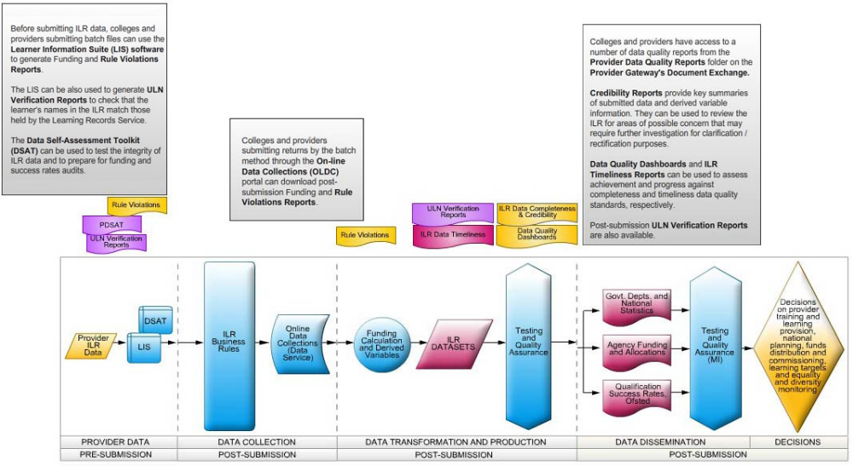

2.2 The Provider Gateway
LINKS and RESOURCES

Link to Gateway login

The Provider Gateway is managed by the Data Service. It holds data about your provision, and a range of reports which are useful to you in reviewing its quality. You can only access the data relevant to your organisation. Ofsted and LSIS can access all providers’ data and reports.

In this Guide, we focus on some of the reports which are under the tab ‘Document List’ in the Provider Gateway. Here you will find a range of reports, summary tables and documents. Those most useful for quality improvement, including judging how well you are meeting learner, employer and local needs, are under the tabs:

- Provider Briefing
- PPR (Provider Performance Report)
- QSR (Qualification Success Rates)
- MLP (Minimum Levels of Performance)
- Framework for Excellence.

However, those under Provider Briefing and PPR are reports written for Ofsted or the YPLA (now the EFA). Not all providers have the same reports, so we have not included them in this Guide as it focuses only on reports which are available to all providers about their own provision, and which can be used for quality improvement.

You may also want to look at the TTG (Train to Gain) Performance Reports, although they are now historical, and the PFM (Provider Financial Management) Reports to consider value for money.

CASE STUDY

Provider A uses financial reports from Provider Online to reconcile payments and predict future payments. This is good financial management. It also uses this information, and the information in the PFM reports, to review how much it receives for each programme and to make an assessment about value for money based on the funding received and the success rates achieved.

2.3 Available Reports

The following reports are available under the Document List tab:

- Provider Briefing:
  - Briefings for Ofsted prepared by the Skills Funding Agency or the Young People’s Learning Agency (now Education Funding Agency)
- Provider Performance Report:
  - Summary Employer Responsive Performance Reports prepared for Ofsted and including equality and diversity data and learners by type of programme

- Qualification Success Rates:
  - Reports of timely and overall success rates by type of programme, including tables showing subject sector areas, level of programme, age bands, regions, local authority areas, gender and ethnicity
- Minimum Levels of Performance:
LINKS and RESOURCES

  - Reports of timely and overall success rates against Minimum Levels of Performance
- Framework for Excellence:
  - Tables summarising learner feedback
  - Tables summarising employer feedback, and verbatim employer comments
  - Reports indicating latest Ofsted grade for overall effectiveness and whether you have achieved the Training Quality Standard
  - Summary comparisons of your success rates with other similar providers
  - A summary of your overall Framework for Excellence scores.

2.4 Reports you can use for Quality Improvement (QI)

In this Guide we help you to use reports which are particularly suitable for QI. These help you to track your performance over a period of time, to take a ‘snapshot’ view of quality, and to compare your performance with groups of providers in your local authority area and region.

Some allow you to make these comparisons by gender, ethnicity and disability, and to analyse and compare performance in subject sector areas.

This data can be combined with your own data to give a wider and more accurate view of performance. For example, you can use your success rate data by subject sector area (SSA) with the data on learner satisfaction in that SSA and the grades and comments for the observation of teaching, training, learning and assessment. Considering these gives you a rounded picture of the SSA, and helps you to identify strengths and the root causes of weaknesses. Remember that Ofsted is very interested in the quality of the learning process, so you should review data from observations and from learner feedback, as well as your success rates.

To find these reports, log in to the Provider Gateway, open the tab Document Exchange, and go to the page which looks like this:

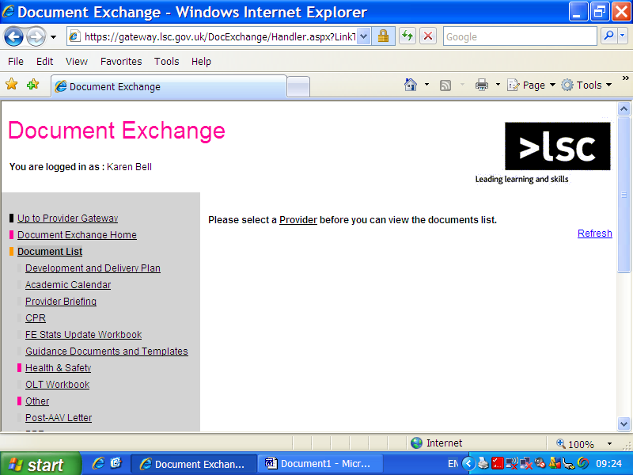
LINKS and RESOURCES

Link to training resource ppt on data to inform*

The reports are available under the tabs on the left.

3. Principles and Themes – Using Data for QI

3.1 Using Data to Inform and Improve

Data can be used to answer questions such as:

“Do we have a problem with apprenticeships in a particular Subject Sector Area?”
“Have we got areas which perform exceptionally well so we can use them to share good practice?”

This approach is fine. It leads you to data which confirms or contradicts your assumptions or hunches. However, you should also approach the data with a fresh and open mind.

Looking at the data afresh, without making assumptions, new patterns may emerge and new insights can be gained. For example, you might be considering your data on timely achievement. Patterns may emerge, or connections; achievement may go down as group sizes and cohorts increase in size. Why? What can you do about it?

You can then add your own data, for example from observations of learning and training, to widen your view and help you decide what actions are necessary to improve quality. In this case, lower achievement might be related to recruitment and guidance, or to teaching which is not effective in larger groups, or to both.

ACTION

Look at your data with an open mind. How would someone from outside of your organisation see it? What would an Ofsted inspector notice and ask about? You can test out your assumptions, and the judgements you make from one set of data, but look also for fresh insights.

CASE STUDY

Provider B has poor retention in the first three months of the programme, so it changes induction to improve the early learner experience. Unfortunately, retention remains poor when a new cohort of learners starts their programme.

What earlier action should Provider B’s managers have taken, before they jumped to conclusions?

Analysing observations and early learner feedback might have identified the root cause of the problem – dull and dreary teaching, and little concern for learners who found the early weeks of the programme demanding for either learning or personal reasons.

3.2 Using Data to Compare – Internally and Externally
LINKS and RESOURCES

Link to training resource*

Link to training resource*

Use Data Service information to compare your performance with that of others in the sector, and to compare different parts of your provision.

Remember that you are still striving for outstanding and that this may more than just being better than others, in particular if their performance is only satisfactory.

Remember also that large percentage improvements can still only indicate satisfactory performance. For example, moving your success rates up from 50% to 60% is an increase of 10 percentage points (and of 20% over the base of 50%), but they are still not good or outstanding at 60%. Indeed, if the national average for that SSA is 70%, you still fall below the mark.

ACTION

Use your data to make comparisons with national, regional or local averages; compare different areas of your provision.

When you do this, remember to make a judgement about quality based on where your provision is now, not how much it has improved. A judgement about how much it has improved (or maintained outstanding), is about your Capacity to Improve.

3.3 Digging Deeper

In many cases, the Data Service reports are a starting point. You will need to use some or all of the following data to dig deeper and investigate root causes:

- Learner satisfaction and employer satisfaction: gained through surveys, interviews, focus groups, complaints and compliments
- Community views of your provision: also gained from a variety of sources, such as meetings of local groups, complaints and compliments, and the views of your learners in a learner forum
- Deeper analysis of learner achievement by category of learner; for example, by trainer and assessor, by work placement, by site or by type of programme, by whether the learners are eligible additional learning support funding, or by ethnic group
- Observations of teaching, training, learning and assessment
- Staff views and suggestions
- Views of other stakeholders; for example, those gained through peer reviews.

Case Study

Provider C uses employer surveys from the Framework for Excellence pages of the Provider Gateway to start its enquiries into quality.

It analyses the data for broad themes and then asks its staff who meet employers to ask two or three questions about these themes. The Quality Manager brings staff together regularly to get feedback from them on employers’ views.

This is also a good example of using own data to reinforce that supplied by the Data Service, and to ‘dig deeper’.
LINKS and RESOURCES

LINKS and RESOURCES

Link to slides on Ofsted use of data*

Link to slides on learner outcomes not just improvement actions*

3.4 Using your own Data

Many providers use the Data Service reports to check their own data. We emphasise in this Guide the need to use your own data day-to-day, and as soon after the event as possible.

Because many work-based learning programmes start and end during the contract year (1 August to 31 July), you will also need to use your own data to investigate problems throughout the year.

Using your own data will give you a variety of sources of evidence to make judgements about your provision, and help you to identify and deal with the problems and areas which need improving. It will also help you to identify successes which you can transfer to other areas.

3.4.1 Value Added and Distance Travelled

There are a number of approaches to measuring the progress learners make between starting a programme and completing it. Wherever possible, measure the distance travelled. You will need to use your own data and data system for this, as there is no nationally recognised way of doing it. You might consider how many learners progress on to a level 3 programme from level 2, and complete it successfully. If those learners started with few qualifications when they began level 2, this can indicate that you have helped them add considerable value.

3.5 Ofsted’s Use of Data

Ofsted will use data from the Provider Gateway to measure risk and to decide whether and when to inspect your provision. When you are inspected, it will use the data to decide on lines of enquiry. These are the areas it will investigate during inspection. For example, if your success rates are static over three years in a particular SSA, Ofsted may well choose to investigate what has been attempted to improve quality, and whether the impact of improvement actions on learners has been measured.

Ofsted expects you to be doing the same, and to be analysing current data so that you can decide on and take improvement actions as soon as possible. For this reason, you should use your own and the Data Service’s up-to-date data. The quarterly QSR reports are invaluable in analysing trends. They can be used to identify problems and successes. Problems can be tackled early, and successes are invaluable to you. You can share the practice around your provision and help trainers, assessors and front-line staff to transfer it into their day-to-day work.

3.6 Data and Action: Measuring the Impact on Learners

Many providers develop excellent action plans based on data. The emphasis of these plans must be on the impact of actions on learners – on their experience throughout the learning journey, and on their achievement, including their progression to further learning and/or work.

When you analyse data, search for root causes, and draft SMART improvement plans which include targets, focus on learner outcomes and then on the actions to achieve them.
LINKS and RESOURCES

A number of the Data Service reports give you information on learner achievement. Ensure your targets for improvement focus on these measurable outcomes, or on others which are directly concerned with learners.

ACTION

For a simple formula, ensure every judgement based on data follows this formula:

Judgement (inadequate to outstanding) - Evidence (data) - Impact on learners

For example: ‘our provision is good; 88% of learners achieve in a timely way and of these, 87% remain in employment in the industry’
4. Examples
LINKS and RESOURCES

Training Resource with these worked examples as slides and handouts*

Link to anonymised report(s)*

Link back to Principles and Themes

4.1 Learner Success, using Qualification Success Rates (QSR)

When you have accessed the Provider Gateway and opened the Document Exchange page, go to the QSR tab under Document List. The screen looks like this:

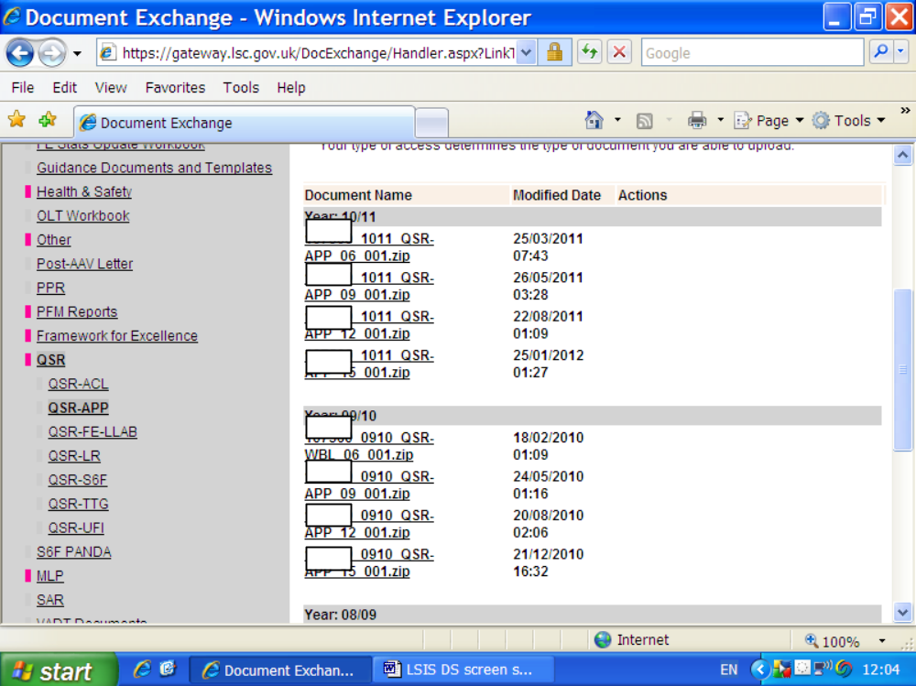

QSR Example Analysis:

We are analysing the anonymised QSR report ‘N’ for the provider with the UKPRN 1000000.

You can start by reading through the report and noting anything at all which catches your attention. Make a note of any questions or sets of data which are not clear to you.

The reports include performance for timely success rates and for overall success rates. Timely success occurs when the learner achieves by or within 90 days of the planned end date for her or his programme. It is a critical measure of quality and of efficiency.

Remember also that some learners complete their programmes in a contract year (1 August to 31 July) after they start. For work-based learning, however, the key point at which to measure success rates is ‘period 15’; that is, the end of October, three months after the end of the contract year on 31 July.

Now, move on to considering page 1 below: the bar charts indicate that overall performance has gone down and is now below national averages.
LINKS and RESOURCES

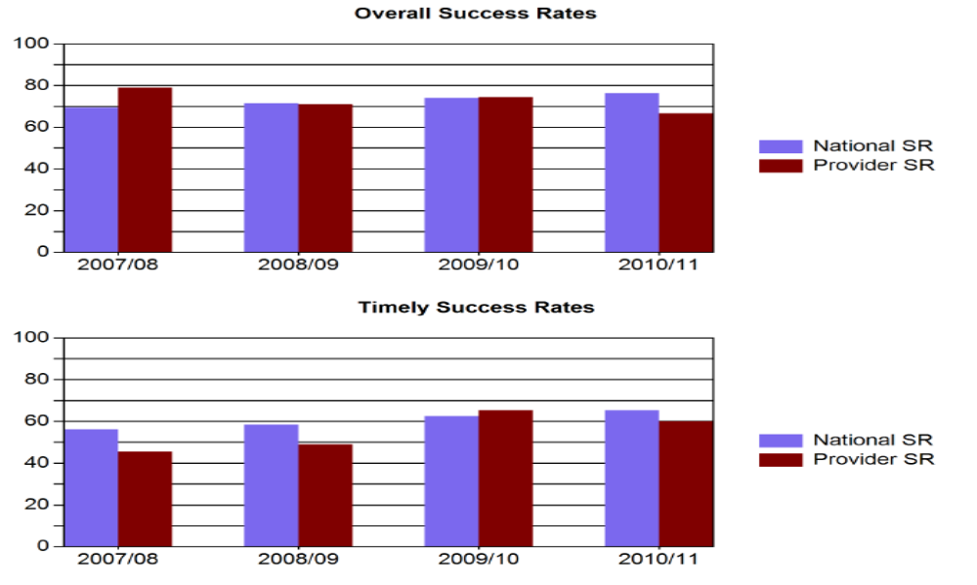

Page 2 below: review the overall and timely success rates for Age Band 16-18; although this provider has a relatively small number of learners, it has grown over the last three years whilst its success rates have declined.
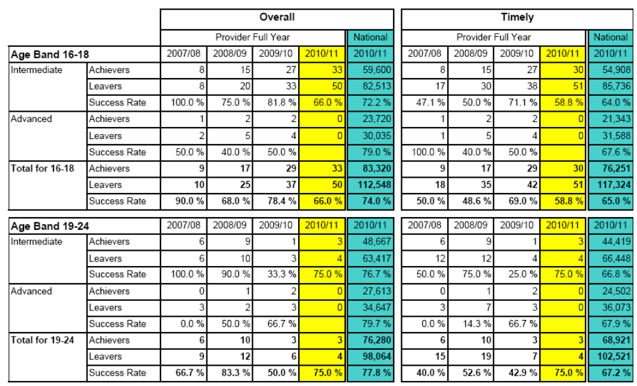

Page 3 below: success rates are now below national averages.

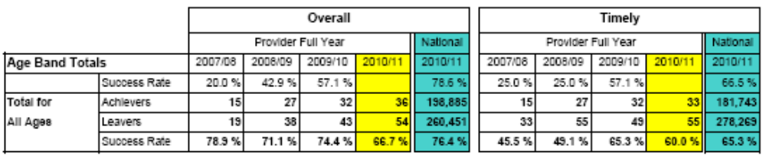

Pages 4 to 12: the tables here show the success rates by SSA; what do you conclude about this provision from them (we suggest you focus on the comparison between the provider’s success rates and national averages)?
LINKS and RESOURCES

To do this, open the QSR Report ‘N’, and review the tables on pages 4 to 12.

Good Questions for Teams and Individuals – the QSR

What do we learn from the headline bar graphs?
What could cause a decline in quality and success rates, when the number of learners rises?
Which of our areas of work are above and below the national average?
Why? If we don’t know, how do we find out?
How do we rate our performance regardless of where we stand in relation to the national averages?
Do we have good or outstanding provision which we can use for staff training; can we transfer this practice to other areas (not just share it, but ensure it can be applied so it will work elsewhere)?

Activity:

Now review your own QSR data; use the questions above to stimulate discussion and to begin to make judgements about your strengths and weaknesses. You can use this format:

Evidence | Analysis

4.2 Making Comparisons, using Minimum Levels of Performance (MLP)

When you have accessed the Provider Gateway and opened the Document Exchange page, go to the MLP tab under Document List. The MLP screen looks like this: (go to MLP-OTHER tab)
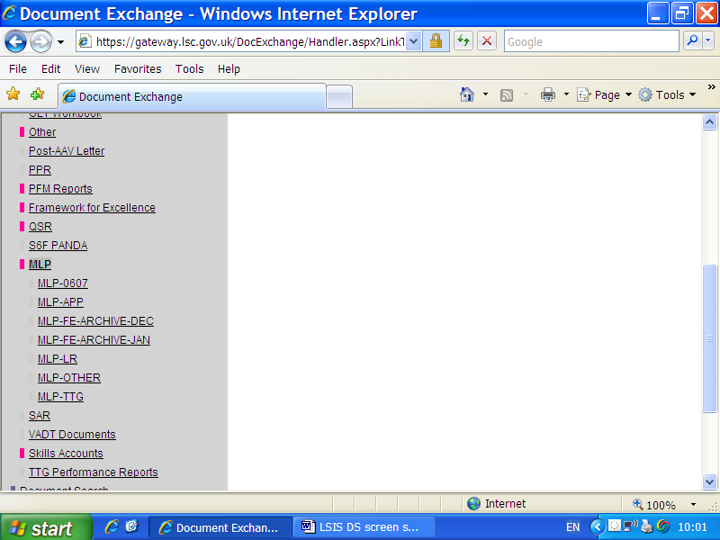
LINKS and RESOURCES

Example Analysis:

We are analysing the anonymised MLP report for the provider with the UKPRN 1000000.

Pages 2 and 3 below give you information, colour-coded, about whether your provision is above or below the MLP.
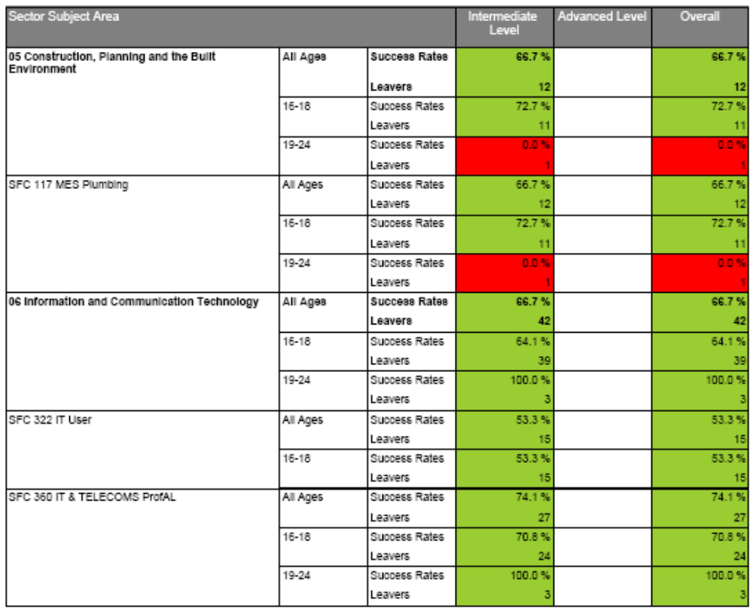
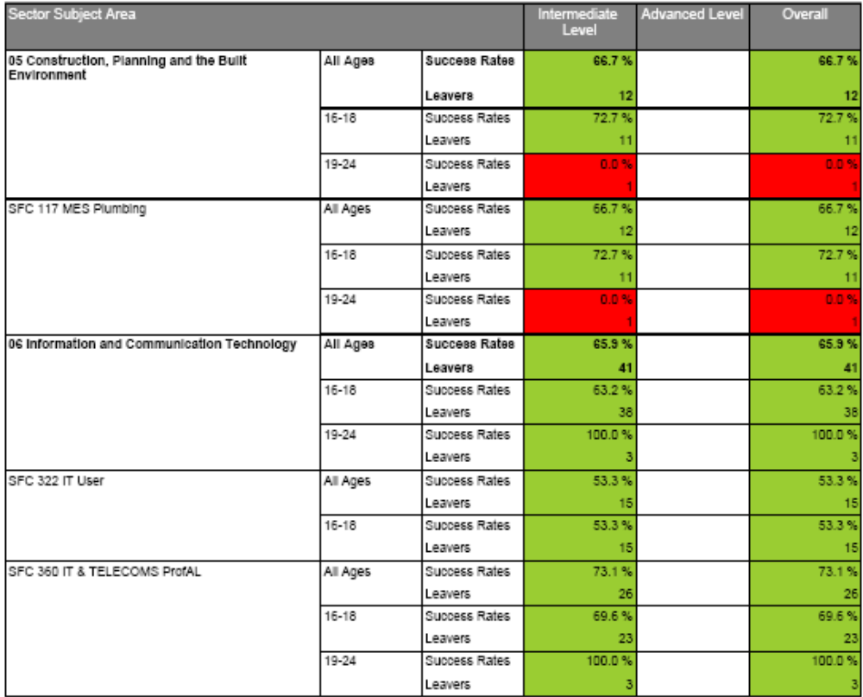
LINKS and RESOURCES

Although above MLP, the success rates for SFC 322 IT User are very close to the minimum. What are the implications?

Good Questions for Teams and Individuals – MLP

Do we have provision close to the current MLP, or even below it?
Why? If we don’t know, how do we find out?
Which areas of our provision will be affected by an increase in MLP? (at time of writing the apprenticeship MLP is 53%)

Activity:

Now review your own MLP data; use the questions above to stimulate discussion and to begin to make judgements about your strengths and weaknesses. You can use this format:

Evidence | Analysis

4.3 Analysing Trends
LINKS and RESOURCES

As well as analysing final outcomes during and at the end of the year, you should indicate trends, for example in learner success rates and learner and employer satisfaction.

Example Analysis:

We are analysing the anonymised QSR report Y for the provider with the UKPRN 1000000.

Page 4 shows success rates over three years for SSA 06, Information and Communications Technology. The Age Band Totals indicate fluctuations for example between 2009/10 and 2010/11 when success rates fell from 81.8% to 65%; this trend is worrying. Note also that the national average is 88.1% in 2010/11.

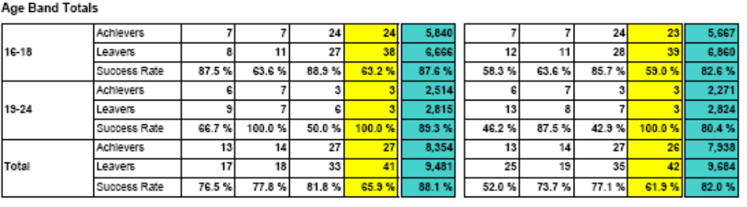

Good Questions for Teams and Individuals – Trends

What is improving?
Why is it improving, and could we transfer this good practice to other areas?
Which areas are maintaining outstanding outcomes?
Why is it outstanding, and could we transfer this excellent practice to other areas?
What is satisfactory, and needs to aim for good and outstanding?
What is above the average but definitely not good or outstanding?
In other words, how do we and Ofsted judge our provision regardless of how it compares to the average? (Ofsted is looking for improving trends and expects you to set robust and challenging targets)
What is declining (even from outstanding to good) and needs urgent action to improve?

Activity:
LINKS and RESOURCES

Now review your own QSR data for trends; use the questions above to stimulate discussion and to begin to make judgements about your strengths and weaknesses. You can use this format:

Evidence | Analysis

4.4 Equality and Diversity

We are analysing the anonymised QSR report ‘S’, for the provider with the UKPRN 1000000. This provides data on success rates by ethnicity and by gender.

Page 3 has a summary of success rates by gender for all programmes. The totals show a marked difference between the success rates for males and females.
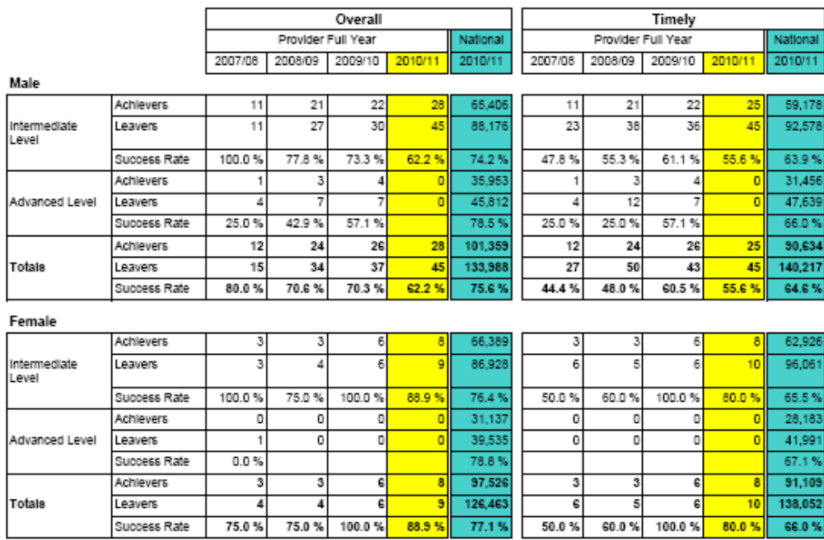

Page 7 shows success rates for Black or Black British Caribbean learners, and page 9 shows these rates for White British learners. These are two of the larger groups of learners. There are significant differences and fluctuations which can be investigated further.

Page 7: Success Rates:

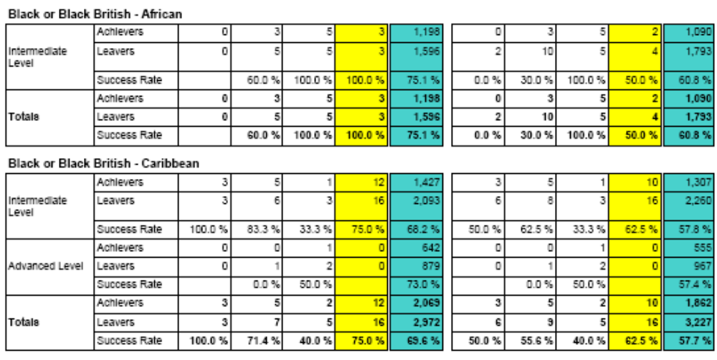
LINKS and RESOURCES

Page 9: Success Rates:

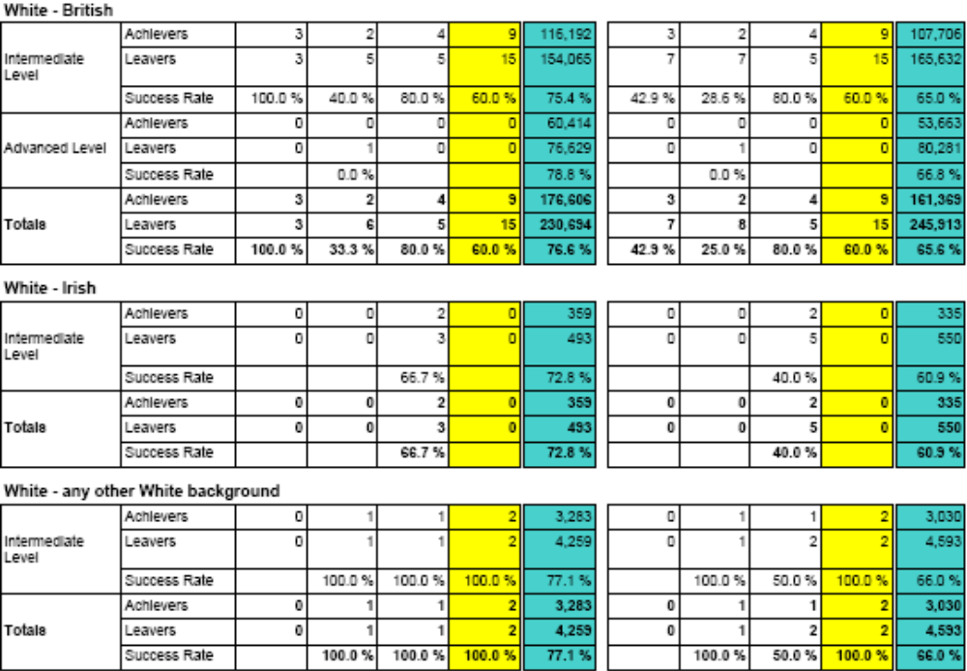

Page 11 shows success rates for learners with learning difficulties and disabilities; this provider has had very few LLDD learners and has none in 2010/11.

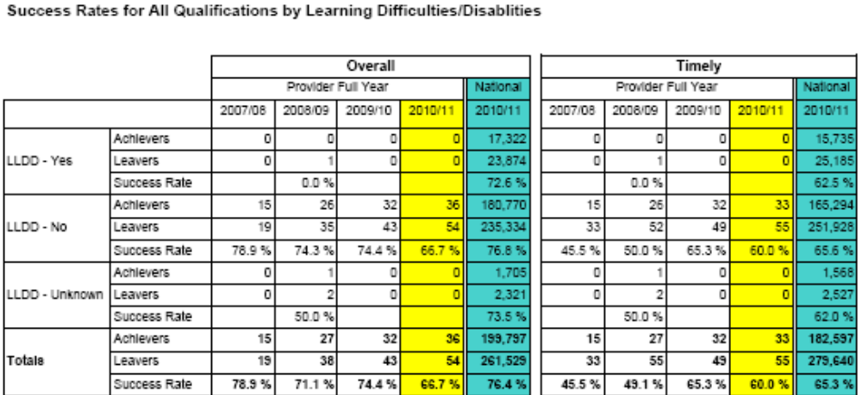
LINKS and RESOURCES

Good Questions for Teams and Individuals – Equality and Diversity

What is the best way to present this complex data?
How about graphs and bar charts – many providers translate Data Service data into other pictorial formats?
Are any groups underrepresented? For example, those with learning difficulties and disabilities?
What are the main differences between groups?
How do we explore the reasons for them?
Some causes: low expectations by learners and provider staff; language and literacy difficulties; approaches to teaching and learning are not appropriate for different groups
Are there groups not indicated in the data which are achieving less well than others? For example: single parents; learners from particular postcodes?
What are we doing to redress any achievement gaps, and how do we show we are successful?
How well are we meeting local and regional needs?
Do the categories of learners which we are recruiting match local demographics?

Activity:

Evidence | Analysis
Now review your own Equality and Diversity data; use the questions above to stimulate discussion and to begin to make judgements about your strengths and weaknesses. You can use this format:

4.5 Learner Recruitment

Example Analysis:

We are analysing the anonymised QSR report ‘N’ for the provider with the UKPRN 1000000.

Page 1 of this report shows you how this provider’s leaver numbers have grown over the last three years. The pages which follow show changes by SSA.
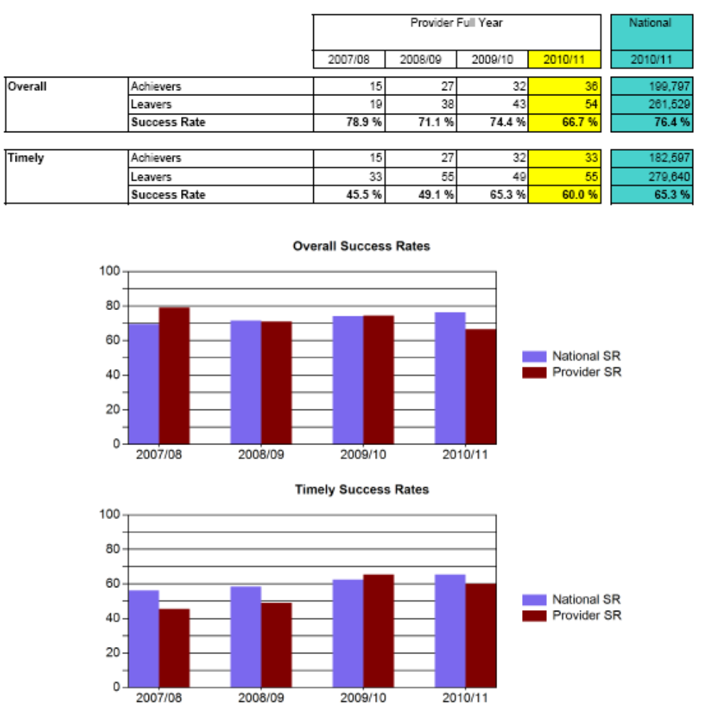
LINKS and RESOURCES

What do you notice about the changes? Which areas have grown most, and fastest?

Good Questions for Teams and Individuals – Recruitment
Have recruitment targets been met?
Are these targets based on a thorough analysis of local and regional needs (or of national needs if appropriate to your provision)?
Are there links between recruitment and quality?
Has quality fallen when numbers have grown, or when they fell?
Why? If we don’t know, how do we find out?
LINKS and RESOURCES

Link to Framework for Excellence site

Activity:

Now review your own QSR data for recruitment trends; use the questions above to stimulate discussion and to begin to make judgements about your strengths and weaknesses. You can use this format:
Evidence | Analysis

4.6 The Framework for Excellence (FfE)

Learner and Employer Satisfaction

The Data Service’s summaries of your Framework for Excellence responses form a useful starting point for further investigation. For example, the reports on employer satisfaction, which include verbatim comments from employers, offer you insights into further questions to ask in surveys, interviews or a focus group.

They may also confirm your own analysis which you are able to carry out during and immediately after learners are on programme.

The Framework for Excellence screen (FfE OTHER tab) looks like this:
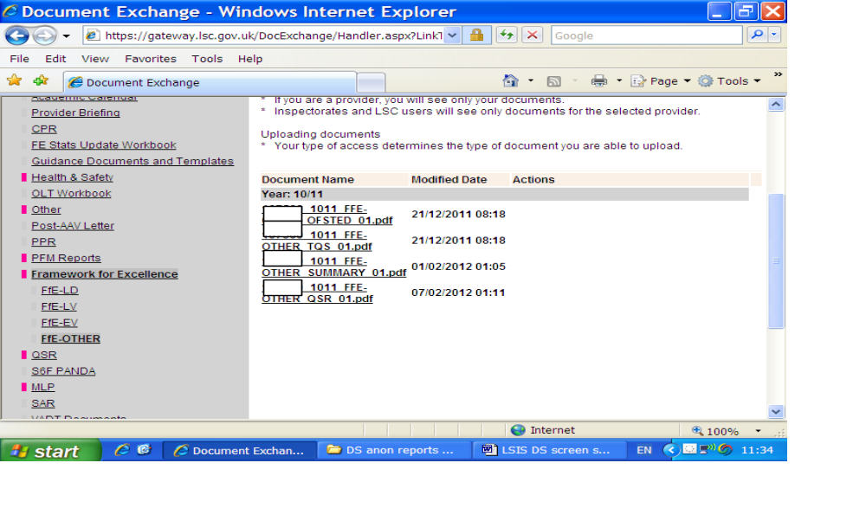
4.6.1 Example Analysis: Employer Voice
LINKS and RESOURCES

Below is a sample page from the anonymised report FfE Employer Voice, for ABC College. It indicates the headings for the Framework for Excellence report.
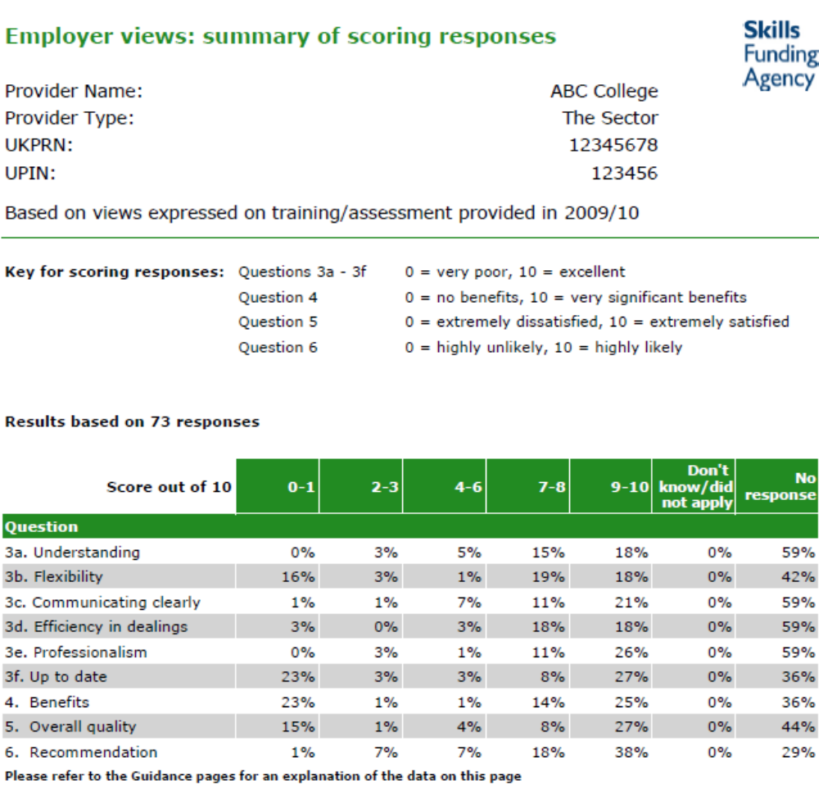

On page 18, below, you will find the responses to the question ‘how good or bad was the provider in communicating with you throughout the (learning) process?’

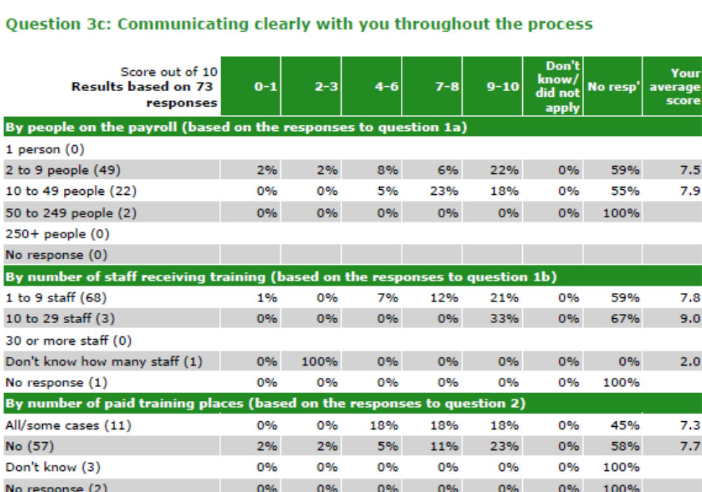
LINKS and RESOURCES

What do you conclude?
Responses vary considerably, with some low scores 0-1, 2-3 and 4-6 which require further investigation.

Now review your own data for employer satisfaction, either using the Framework for Excellence Reports or your own feedback on employer satisfaction.

You can use this format:

Evidence | Analysis

Good Questions for Teams and Individuals – Employer Satisfaction
What are our strengths and weaknesses generally?
What do we need to know more about?
How do we find out more – interviews, focus groups, using assessors and others to get feedback and dig deeper?
How well do we measure the impact of our training on employers’ businesses?
What actions should we take to deal with the root causes of our weaknesses?
How do we use our strengths to transfer good practice to areas which need it?
How well do we involve employers in quality improvement, including telling them about changes resulting from their feedback, or the reasons why we have not made changes?

LINKS and RESOURCES

4.6.2 Example Analysis: Learner Voice

Below is a sample page from the anonymised report FfE Learner Voice, for ABC College. It indicates the headings for the Framework for Excellence report.

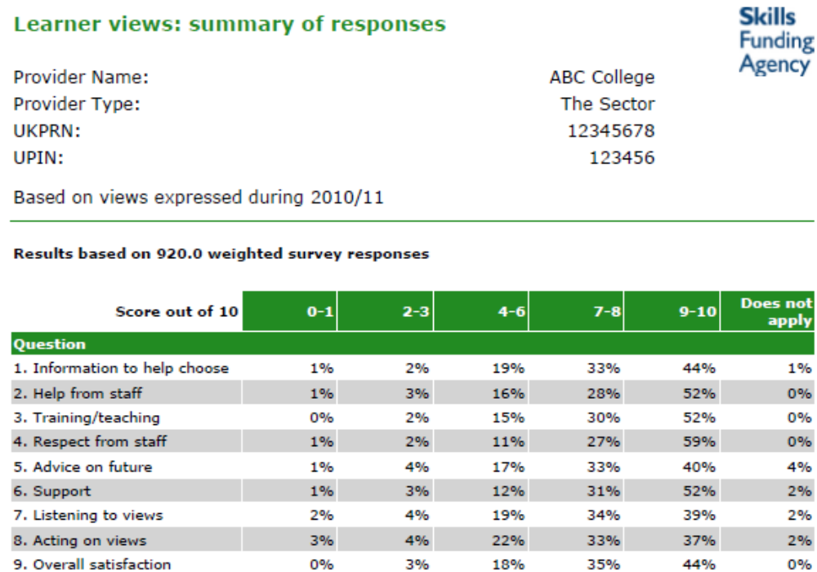

On page 10, below, you will find the responses to the question ‘how good or is the teaching/training on your course/programme?’

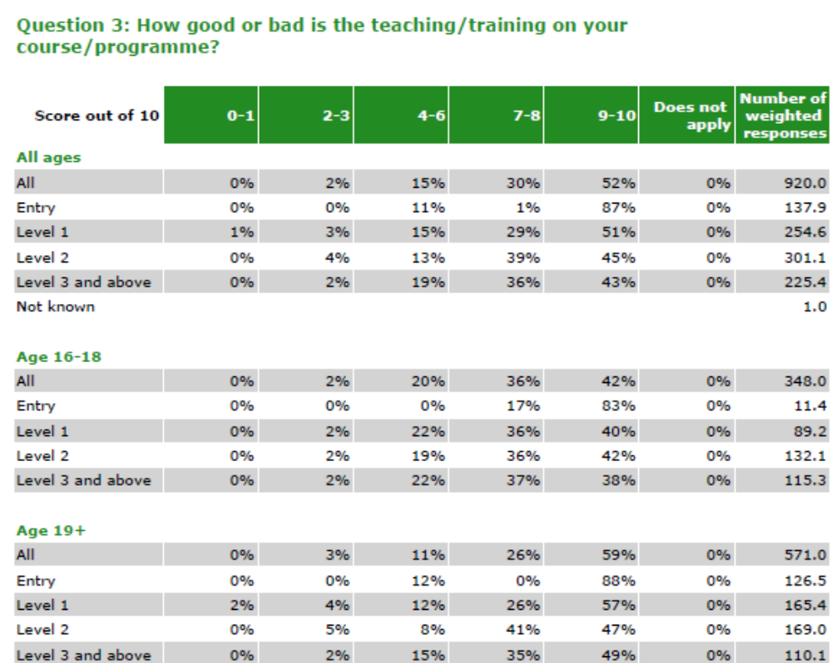
LINKS and RESOURCES

What do you conclude?
Responses vary considerably; satisfaction with teaching/training is much greater on entry level courses.

Now review your own data for learner satisfaction, either using the Framework for Excellence Reports or your own feedback on employer satisfaction.

You can use this format:

Evidence | Analysis

5. Evidence for Leadership and Management

The data which you have analysed from the QSR is valuable in judging leadership and management in your provision. On the basis of the information, you can judge how effective you are at raising learner achievement. Ofsted will consider this data carefully before and during inspection.
LINKS and RESOURCES

5.1 Working with Partners and Subcontracting

An essential part of partnership working and subcontracting is shared analysis of performance data. Review outcomes at least quarterly with your partners, either your lead provider or your subcontractor(s).

There is more guidance and examples of this in the resources developed by the LSIS Minimum Contract Level Support Programme.
Case Study

Provider D is a lead provider with four subcontractors. It has agreed a quality manual and set of protocols with its subcontractors. Reviews take place at least quarterly.

A key feature of the protocols is that subcontractors agree to report any problems in learner success rates as soon as they arise. Provider D then works with the subcontractor to define an improvement plan, sometimes drawing on the expertise of its other subcontractors, if appropriate.

There is a financial incentive for subcontractors to disclose problems, as delaying disclosure will lead to problems later and the risk of contract run-down or even early termination.

6. Evidence for Self-assessment and Improvement Planning

Any judgement made by any individual, department or team as part of your improvement plan and/or self-assessment report must be backed up by data. This data has to be reliable, up-to-date and relevant to the judgement. For example, if you are making judgements about your responsiveness to community needs, you need to define what you mean by ‘community’, what indicators of responsiveness or success you are using, and how you measure them. The data you use must relate to the indicators, and every indicator should refer to impact on learners.

Some of your data will be annual outcomes for learners (self-assessment report data), whereas other data (live data) will be gathered during the year (improvement planning data) to provide specific information for analysis and fast action. Use the Data Service to provide both historic and current data.

6.1 Historic data – ‘high level’ headlines

The Data Service provides a considerable amount of historic data. This is high level and available usually some time after programmes end. However, the QSR provides regular reports which can, with some additional data of your own, provide current low level information. For example, you can track cohorts of learners through their programme, focusing on particular aspects such as the achievement of males or females, or from different local authorities.
LINKS and RESOURCES

6.2 Current ‘low level’ data about learners who are on-programme

You should use current data which focuses on learners who are on-programme. This is low level data which should be used on a regular basis as part of your strategy and improvement planning. Low level data is ‘immediate’, and leads you to appropriate action to improve and to limit risk. For example, you can use current data such as attendance to identify learners who are disengaged and may drop out of their course. This potential dropout will reduce the number of learner outcomes, which will in turn affect your high level data – your organisation’s success rates.

6.3 Making judgements using qualitative and quantitative data

Your data can be quantitative – for example, learner success rates or numbers of employers engaged, or qualitative – for example feedback from learners throughout their learner journey, from employers, and from other interested people (stakeholders) on their satisfaction with your provision and service.

It is important to compare the data against your targets, and to ensure that it is validated. Learner outcomes (including destinations and progression) are key sources of information for you in making judgements and monitoring improvement; so are the results of your observations of teaching, training and learning. Your processes and judgements for observation should be based on clear criteria. You need trained observers who can stand back and take an objective view of learning – whether they are from inside or outside of your organisation.

If you subcontract provision, you must ensure that your subcontractors have reliable data to inform their and your judgements. You may want to sample their observations or learner outcome data.

7. Getting Everyone on Board

Effective providers ensure all their staff are using appropriate data so that they can analyse their performance and improve it where necessary.

The resources provided help any member of staff, including support staff, to understand how important this is, and to use data to improve the quality of the work they do and the service they offer to learners. Data Service data is often a starting point for further investigation by sections, teams and individuals.

8. Other Sources of Data for Improvement and Ideas on How to Use It
LINKS and RESOURCES

You can also use these sources for data and for tools and tips on how to apply it for quality improvement;

The User Guide to Self-assessment and Improvement Planning has tools to help you use data effectively.

The Prepared for Inspection Toolkit is a free on-line resource with sections on using data. It is in the LSIS Learning Environment as a course. You will need to register with the Learning Environment to use it.

FE Choices is a website which provides information for learners and others about providers. Some providers have used this information to make comparisons between their and others’ provision.

The Excellence Gateway has resources and case studies about the effective use of data.

9. Jargon and Acronyms not explained in the Guide

Education Funding Agency – EFA (formerly YPLA, Young People’s Learning Agency)
Funds the education system for 3 to 19 year-olds (up to 25 for learners with disabilities
MLP – Minimum Level of Performance
An overall minimum success rate set by the Skills Funding Agency; if performance falls below this level, contracts from the Agency will not be extended and will ultimately be terminated
National Average
The mean success rate for providers from the sector (that is, all providers and colleges with a Skills Funding Agency contract), or the mean success rate for the group of providers indicated
National Apprenticeship Service - NAS
Supports, funds and co-ordinates the delivery of apprenticeships throughout England
Skills Funding Agency – the Agency
Funds and regulates adult further education and skills training in England
Success Rate
Success rates are calculated as the percentage of leavers (for whatever reason) in a year who leave with the full planned qualification or set of qualifications.

